
Branch
in Ust-Ilimsk Region

APPROVED BY
Director of Branch
JSC Ilim Group in Ust-Ilimsk Region
of Irkutsk Oblast

I.A. Koroteyev
____ _______________ 2016

INSTRUCTIONS

on safety measures for taking actions aimed at prevention of spread of forest fires

No. 10100-03-16

To replace No. 10100-06-34 approved by the order
No. 246 of 06.06.2014

Introduced by:_
(type of the document, date, document number)

Introduction date: ______________________
(day, month, year)

Ust-Ilimsk
2016

1. PURPOSE
This instruction establishes the procedure for the safe organization of work by the unit employees during taking actions aimed to prevent the spread of forest fires (hereinafter “taking actions”) in the lease base of the Branch of JSC Ilim Group in Ust-Ilimsk Region.

SCOPE OF APPLICATION
This instruction shall apply to all units of the Branch of JSC Ilim Group in Ust-Ilimsk Region.

REFERENCES
  - For the purpose of development of this Instruction the latest versions of the following external and internal document requirements were taken into account:
- The Federal Law On Fire Safety No. 69-FZ of 21.12.94;
- Rules for fire safety in the forests, approved by the Governmental Decree of 30.06.2007 No. 417;
- Rules for operational safety in timber harvesting, wood processing industries and forestry works, approved by the Decree of Ministry of Labor and Social Development of the Russian Federation of 21.03.1997 No. 15;
- Fire safety regulations in the JSC Ilim Group (approved by the order of General Director of JSC Ilim Group of 25.02.2011 No. 36)

4 General safety requirements
4.1. Types of fires:

Creeping fire
This fire burns grass, moss and lichen, bushes, overturned trees and fallen branches, fallen fir needles and leaves. It also often burns tree trunks but leaves the tree crowns intact. Speed of creeping fire spreading directly depends on the terrain and wind speed in the surface layer. If creeping fire spreads in windy weather, especially in spring, it can develop into running fire, when many new spots are rapidly catching fire. In a calm weather this type of fire develops as an independent fire, with a slower spread of the burning edge but with total burnup of all combustible materials on the affected area. If the fire develops under dry and windy weather (especially if there is a slope steeper than 200 or there is a lot of spruce undergrowth in the forest), then it can develop into crown fire. Flames height in creeping fire edge depends on the amount of combustible materials, temperature, humidity and wind speed. Fire with flames height of 0.5 m max is considered weak, 0.5 to 1.5 m – medium and over 1.5 – strong.

Crowning fire
The entire forest territory is on fire, flames engulf the tree crowns. Fir forests are the most prone to crowning fires, foliose (e.g.) oak forests are less susceptible, but can also be caught in a crowning fire in seasons when mostly dead leaves can be found on the branches. As a rule, this type of fire emerges as a creeping one, but in conditions of dry windy weather in develops into crowning fire. This development can be based on big amount of windfall, spruce undergrowth, fir undergrowth adjacent to more mature fir forest stands, and steep slopes. Usually crowning fire is most active during day hours, descending in the evening into creeping one as humidity rises and the temperature drops. Crowning fire is always “fed” by ascending thermal fluxes from conflagrant surface combustible materials. Crowning fire can “leap” up to 100-300 meters ahead, but then it slows down, “awaiting” for the creeping fire to develop under the burning crowns. Crowning fire can also be subdivided into running and independent fires by their spreading nature. Crowning fire spreading speed also depends on type of terrain, humidity and wind speed. Crowning fire (and forest plots where they can emerge) is only extinguished by indirect means of fire-fighting, by creating mineral-based fire lines and vegetation clearance. Sometimes the advance of a crowning fire can be slowed down with the use of aviation (jettison of water by jet bombers and spillway devices from helicopters), but it is the work of land-based groups that create blacklines insurmountable for a fire that is of decisive importance. In case of medium and strong crowning fires, a convective column is formed – a powerful ascending flux that raises burning particles (small branches, fragments of the bark, etc.) hundreds of meters (sometimes kilometers) high. If the convection column takes inclines (due to wind) or forms a "fracture" under the influence of wind at a relatively small height, burning particles outside the fire contour cause the formation of new foci and the fire begins to spread in “spots”. Such fires are most dangerous and complex in extinguishing.
4.2. Dangerous aspects of forest fire.
Dangerous aspects of forest fire can be subdivided into following groups by their level of hazard for human health:
a) Fire is the main reason for injures and deaths when people get trapped in the fire. When extinguishing the creeping fire edge, burns over the exposed body parts or clothes catching fire are the most common cases. Means of protection that can be used to prevent that are protective clothes, tents, blankets made of non-combustible cloth.
b) Smoke: major problem in high smoke concentration is decreased visibility. High smoke concentration in the air (over 600 mg/l) causes irritation for eyes and respiratory passages. Long exposure to smoke causes loss of consciousness and even more serious consequences. Means of protection from smoke are respirators with protective goggles or gas masks.
c) Fall of burnt and dead trees is a factor that not only often causes injuries, but also death of people, and is itself caused by violation of safety rules. It is an obligatory to wear helmets for head protection while extinguishing fires.
d) Increased temperature, for human body is susceptible to heat. At an elevated body temperature (up to 40 °C), a thermal shock may occur, resulting in convulsions, loss of consciousness, etc. A person can tolerate a temperature of 65 °C only for a limited time, a temperature of 145 °C for 5 minutes, and at 175 °C causes irreversible skin damage to occur in less than 1 minute. Exposed areas of the body is protected from increased temperature by using protective clothing made of non-combustible fabrics and glasses, etc.
e) By getting to open areas of the body sparks can cause burns, or sometimes lead to combustion of clothing or shoes. Non-combustible fabrics for protective clothes or special protective face shields can serve as protective means.
f) There is a psychological factor, i.e. fear, panic, discomfort, which are the result of poor training of people working on extinguishing forest fires. Confidence is achieved by psychologically training people, by proper organization of work, exercises and reliable personal protective equipment and tools.
g) Noise creates a hindrance to perception, makes it difficult to organize work, leads to premature fatigue. It is necessary to provide the workers with speakerphones and radio sets.
4.3. Men between the ages of 18 and 60, bearing no physical disabilities and under condition of undergoing a preliminary medical examination at their place of work, and deemed fit for this type of works are allowed to participate in the actions preventing the spread of forest fires. Women aged between 18 and 55 (except for pregnant and lactating women) fit for this kind of job may be involved in auxiliary works in the fight against forest fires (domestic services, cooking, keeping duty, etc.).
4.4. To guide the actions aimed at preventing the spread of forest fires, a trained engineering technician instructed in technique and tactics of actions aimed at preventing the spread of forest fires, as well as timber resource base of the forestry enterprise is assigned as unit manager.
4.5. Heads of production units that supervise employees comprising the GBFFTs in acting against the spread of forest fires, are obliged:
- to list the names of employees sent for taking actions aimed to prevent the spread of forest fires and trained in this type of works, as well as assign a group supervisor;
- provide workers with serviceable protective clothes, special footwear, personal protective equipment (helmet, respirator, protective goggles or face shield, signal vest, cotton gloves), field equipment (tent, electric lantern, enameled bucket, utensils, aluminum canister for potable water of 20 l capacity), axe, shovel, etc.), individual medical packages and first-aid kit, 3-day food supply, insect repellent, serviceable fire equipment.
4.6. Persons assigned for taking actions aimed to prevent the spread of forest fires shall be provided with potable water directly in their place of work. If there are no potable water sources in place, the water shall be delivered in closed vessels (tank, thermos bottle, flask, etc) in the amount of 5 to 6 liters per person per shift.
4.7. When conducting works in tick-borne encephalitis-infested areas, the workers shall have preventive vaccination.
4.8. Leader of the group shall check the whole group names against the GBFFT list of trained persons before sending the group out.
4.9. Group leaders shall receive lists of workers, a forest fire map (scheme) of the area, medical first-aid kits and supervise the availability of personal protective equipment, food, and serviceable fire-extinguishing equipment.
4.10. Persons assigned for taking actions aimed to prevent the spread of forest fires shall undergo a special training in safety measures provided by the official responsible for appointing people for taking actions aimed to prevent the spread of forest fires, against mandatory registering in the Registration Log for Safety Instructional Briefings. Besides, the workers shall be instructed on the nature and type of fire, pointed out the most dangerous areas, resting places, shelters, and passage ways that lead to them.
4.11. Delivery of groups (teams) for taking actions aimed to prevent the spread of forest fires shall only be conducted during day hours.
4.12. All the work on taking actions aimed to prevent the spread of forest fires shall be based on strict discipline and direct supervision principles. Direct orders of the supervisor shall be mandatory for all the direct reports.
4.13. It is strictly prohibited for the employees suffering from alcoholic or narcotic intoxication to be transported or take actions aimed to prevent the spread of forest fires. An employee engaged in taking actions aimed to prevent the spread of forest fires shall only perform the works that were assigned to them by the supervisor or the leader of the group.
4.14. In case of lightning storm, all actions aimed to prevent the spread of forest fires shall be ceased, all radio sets shall be off, all antennae shall be turned off and grounded, and all the metal tools shall be brought to a pre-defined place. The employees shall assume a safe position in a clearing or in an underbush, inside terrain folds, on a hill slope, between trees that grow 20 to 25 meters across.
It is prohibited to seek shelter from the rain under separate trees, triangulation and observation towers, to touch the supports of high-voltage lines, communication line wires, antenna leads and counterbalances.
4.15. Operating fire-fighting machines and equipment is not permitted without appropriate signaling tools, measuring devices for monitoring the main parameters of operation modes, protective fencing of the operator's cabin, or in case of violation of the safety requirements set forth in the operation manuals for technical equipment.
4.16. All the actions aimed to prevent the spread of forest fires, including cutting, hauling, cross-cutting, stump extraction, soil cultivation, removal and transportation of soil, shall be organized in accordance with the Labor Safety Rules for the Timber Harvesting and Woodworking Hndustries and for Forestry Management Works, approved by the Decree of the Ministry of Labor and Social Development of the Russian Federation of 21.03.1999 N15 and agreed upon with the State Forest Committee of Russia and the Central Committee of the Trade Union of Forest Industries Workers.
4.17. Leader of group and the head of structural unit shall establish reliable telephone or radio communications between the employees involved in taking actions aimed to prevent the spread of forest fires.
4.18. Persons engaged in taking actions aimed to prevent the spread of forest fires are not entitled to leave their place of work on their own, without the permission of the group leader, except in cases of extreme danger, as well as in case of carbon monoxide poisoning, injury or burn.
4.19. Before sending people for taking actions aimed to prevent the spread of forest fires, a group leader must be appointed for each group. This person shall have lists of people engaged in taking actions aimed to prevent the spread of forest fires and periodically check the people in the group against these lists.
4.20. Upon delivery of people to the place for taking actions aimed to prevent the spread of forest fires and upon their extraction by helicopters, it is necessary to use registered or temporary airports, landing sites, and the following requirements shall be met:
- number of transported person shall not exceed the number of fixed seats;
- nobody shall approach the helicopter until its rotor come to a full stop, and until the pilot gives the related permission;
- approaching a helicopter should be done under the pilot’s direct supervision;
- it is prohibited to approach the anti-torque tail rotor;
- workers suffering from alcohol intoxication or illness that can create risk for the affected person or other people, are not allowed to be transported;
- landing (unloading) with operating rotor shall be effected in the direction of the entrance door at an angle of 45 degrees to the longitudinal axis of the helicopter from the forward side of the fuselage, for the KA-26 helicopter only from its aft quadrant;
- landing (unloading) of the workers in the hovering mode is only allowed in case if it’s impossible to land the aircraft;
- it is prohibited to smoke in close proximity to the aircrafts; smoking area shall be at least 50 m far from the aircrafts; it is also prohibited to start a fire in the landing area.

5 Organization of safety measures for taking actions aimed at prevention of spread of forest fires
and safety requirements for commencement of works
5.1 Stages of preventing the spread of forest fires

Detection
Forest fire is a spontaneous uncontrollable spread of fire through the forest area. On the leased plots of the forest of JSC Ilim Group in Irkutsk Oblast there can be two types of forest fire: creeping and crowning fire. Timely detection, i.e. in the shortest time after the fire occurrence, is an important element in the localization and subsequent elimination of forest fire. It provides an opportunity to start extinguishing the fire while it’s still developing, which simplifies the task and significantly reduces costs and losses. Detection of forest fires is effected through satellite monitoring, aviation supervision of forests and ground patrolling by the Forestry Agency.
Scouting
After detection and receipt of information on the forest fire from Forestry Division, scouting activities are carried out. For this purpose a group of at least two people from the Forestry Division personnel of the Branch is sent to the site of the fire. Group leader shall have the following: map documents, navigator, a radio set for communication with the vehicle on duty, and a radio set for communication with an air patrol aircraft and a helicopter. It is necessary to define wind direction during the scouting activities which also will allow to define the fire spread direction.
For the purpose of safety it is necessary to approach fire from the rear or from the sides. It is necessary to use every opportunity to obtain information from patrolling aircraft.
Before starting actions aimed to prevent the spread of forest fires, the team leader shall organize additional scouting of the fire scene, determine its boundaries, direction and speed, and upon obtaining this information conduct a training. Also:
- indicate safe places (shelters) in the clearings, in foliose forest stands, on the banks of water bodies, along roads; as well as pass ways to them, appoint guides that would be directing the workers to shelters from unfamiliar terrain;
- indicate recreation facilities and night rest spots, also working and rest schedule;
- inform workers on the map (scheme) and on the terrain on the landmarks of the location of the forest fire, moving it further from the nearest settlements, and transport routes;
- arrange the workers and determine the ways and tactics of taking actions aimed to prevent the spread of forest fires in accordance with the characteristics of the fire.
Elaboration of the operations plan
Based on the scouting results, the group leader draws up a fire scheme and composes operations plan for taking actions aimed to prevent the spread of forest fire. The operations plan determines the necessary number of groups and their numerical composition, amount of necessary equipment, passage ways for people and equipment to get to the fire scene. Mineral-based fire lines location shall be drawn up with the help of special equipment and manually. Group arrangement is planned for the groups to guard the edge of the fire. All information shall be transferred to a unified logistics center and Branch headquarters for preventing the spread of forest fires for rapid response.

When developing actions to prevent the spread of forest fires, a unified approach to the names of individual elements of the fire is needed, which will ensure mutual understanding in future actions.
Forest fire elements
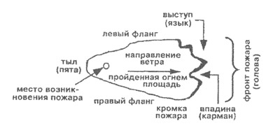
fire front
(head)
protrusion (finger)
left side
right side
rear
(toe)
fire origin point
wind direction
burnt area
fire
edge
lacuna
(recess)

Guarding

Guarding is a necessary stage for taking actions aimed to prevent the spread of forest fire. Guarding shall be effected by a group of not less than 2 workers. During guarding. it is necessary to monitor the fire edge by following the file perimeter. Upon detection of a renewed fire scene it is necessary to take actions aimed to prevent its further spreading.
The information on fire elimination shall only be transmitted only when the fire department leader decides to end the guarding stage, confirming that the fire can not resume on its own.

5.2. It is prohibited to appoint workers for direct extinguishing of fire my manual tools in case if the fire edge is spreading rapidly and flames height is over 1.5 – 2 m. It is feasible to postpone the extinguishing of this kind of fire edge to morning hours, when combustion intensity decreases.
5.3. Recreation and night rest facilities shall be located not closer then 100 m from the edge of the contained fire scene and fenced in (entrenched) by mineral-based fire lines minimum 2 m wide. Provide for creation of new fire lines for the event of fire outbreak. All dry and dangerous (inclined, rotting, etc) trees within a 50 m radius shall be cut down. For the period of rest, workers on duty shall be assigned. When taking actions aimed to prevent the spread of large forest fires or rapidly-developing fires, a 24-hour watch shall be organized at the camp, as well as wind direction and strength monitoring duty. It is prohibited to make a night rest facility within an active forest fire edge zone and in the spruce undergrowth.
5.4. The group leader and group supervisors bear personal responsibility for the organization of work, for the safety of workers during the taking actions aimed to prevent the spread of forest fires and shall periodically monitor workers presence at the fire site. Order and time of group meeting shall be indicated by the group supervisor before the beginning of works. In case if someone of the workers has gone missing, a search shall be organized immediately. Search results shall be reported to the group leader directly. Group supervisors shall have under their control groups of people that can be easily controlled, maximum 10 workers.
5.5. Upon receipt of a weather forecast from the weather station on wind speed increase or sudden increase in temperature, floods or other dangerous natural phenomena, the leaders of the the fire extinguishing teams, leaders of the air-force divisions, piloting observers shall inform the group leader about this forecast in order to be able to take measures to prevent the spread of forest fires.
5.6. Before start of works, workers shall prepare their tools, fire-fighting equipment, personal protective equipment, check and prepare protective clothing and shoes.
5.7. When operating technical equipment, the operators shall check the integrity of all assemblies, availability of alarms, lighting, check the engine operation at idle, and also the availability of the property necessary to complete the fire bulldozer used to take actions aimed to prevent the spread of forest fires.

6 Taking actions aimed to prevent the spread of forest fires
and safety requirements during works
6.1. Taking actions to prevent the spread of forest fires shall be carried out by groups of at least 2 people, but not more than 10 people, one of whom shall be appointed supervisor based on the group leader instructions.
6.2. During taking actions aimed to prevent the spread of forest fires, workers shall use personal protective equipment, including protective face shields.
6.3. During taking actions aimed to prevent the spread of forest fires, it is necessary to monitor the burnt dead wood, timely remove it in the direction of the fire in order to avoid sudden falls.

Actions aimed to prevent the spread of forest fires are a series of consecutive operations that correspond fire development stages.

STAGES FOR THE ACTIONS

Actions aimed to prevent the spread of forest fires |  | Stages of forest fire development
Break-out and initial stage
of forest fire
Initial stage involved containment
on main directions, prevention
of fire spreading
 |  | Decreasing of development activity
Taking actions on preventing the
fire edge spreading,
partial containment
Partial arresting of
fire spreading
Containment and final extinguishing, elimination of separate combustion scenes over the containment line
 |  | Full arresting of forest fire spreading
Guarding and final extinguishing
of newly broken-
out fire scenes
 |  | Forest fire elimination

6.4. To maintain efficiency in conditions of severe smoke screening and high temperatures, workers shall only operate in the immediate vicinity of the fire for no more than 30 minutes. Workers are allowed to go back only after a short rest outside the smoke-screened zone and away from the thermal impact of the fire, when their working capacity is restored.
6.5. When taking actions aimed to prevent the spread of forest fires, it is necessary to:
- maintain a distance of not more than 3 meters between the workers;
- not lose sight of workers operating next to each other, constantly monitor their movement visually and carry out a regular vocal check;
- in case if a worker gets rounded by an edge of an active fire – the worker shall pull back, immediately inform the group leader (supervisor) about the current dangerous situation, warn the nearby workers about the danger;
- in order to prevent the workers and equipment from being surrounded by fire, group supervisors shall maintain constant monitoring over the fire spreading direction. Groups that operate away from the main body, shall be monitored or communicated regularly over the radio.
6.6. The following is prohibited during taking actions aimed at prevention of spread of forest fires:
- be located higher than the fire edge on a steep (over 20 degrees) non-burnt slope, if the slope is covered with spruce undergrowth, bushes, accumulations of other combustible materials;
- be located in front of the fire in narrow hollows, valleys and nicks;
- throw windfall, stones, etc from the fire edge.
6.7. When taking actions to prevent the spread of forest fires by preventive burnout, the group leader and group supervisors shall ensure that there are no people and equipment between the front of the fire and the preliminarily burnt support line, and only upon that should a signal be given on the ignition of the ground vegetation.

Support line shall be drawn on a safe distance from the fire edge, with due regard to the fire spreading speed. In case of running crowning fire, workers shall not be located closer than 250 m from the fire front (i.e. not less than double distance of possible fire leaps). Preliminary burn-out for containment of running crowning fires shall be effected during day or morning hours.
6.8. Before taking actions aimed to prevent the spread of soil (peat) fire, scouting shall be organized to determine the boundaries of the fire. Determined fire boundary should be marked by flags or any other makeshift means. Workers taking actions aimed to prevent the spread of soil (peat) fire shall constantly monitor falling trees and warn of the danger those who work close to them. It is prohibited to cross the pre-determined boundary.
6.9. When fighting fire with water or chemical solutions, it is necessary for the worker to be located on the windward side at the edge of the fire, where the products of combustion and quenching are harder to be inhibited by respiratory system.
6.10. When taking actions aimed to prevent the spread of forest fires by means of a bulldozer, workers shall not be located in front and from behind of the operated unit for at least an area equal to a double height of an average tree. Bulldozer operation shall be coordinated by a signalman appointed by the group leader. Signalman shall indicate movement directions, monitor spread of the fire and fire leaps through the support line, and warn of the danger. It is prohibited to use equipment with faulty engines or leakages in the fuel system, and to fuel the engines near the fire when taking actions aimed to prevent the spread of forest fires. It is necessary to remember at all times that there is a chance of instant combustion of flammables during fire.
When using heavy tractor machinery in taking actions aimed to prevent the spread of forest fires it is necessary to:
- move people away from the operating machinery at a safe distance;
- make sure all bulldozers (tractors) in operation are serviceable, are equipped with operational flame arresters and safe operator cab;
- creation of mineral-based fire lines is preferred over as gently-sloping areas as possible, understocked and divested of forest-based combustible materials (FBCMs);
to increase efficiency and safety it is preferable to use paired tools, especially when the work is carried out near a fast-moving edge;
- be able to cross-cut lying logs (clean woods, windfalls), cut down live and dry trees;
- push FBCMs by the tractor blade outside from the mineral-based fire line, except for cases of direct extinguishing, when burning FBCMs should be pushed inwards, to the fire source, and be dissipated;
- not allow unauthorized persons to operate technical equipment;
- while extinguishing, push large logs (trees) or burning debris to burnt area, then wedge the debris away along the outer side of the mineral-based fire line;
- ensure reliable connectivity with the group leader when working in close proximity to the burning edge;
- have forest backpack extinguisher charged and at the ready.
6.11. Operation of various technical equipment, observation towers and masts shall carried out by specially trained workers with a certificate that confirms their entitlement to perform these works. Safety measures for operation of fire extinguishing equipment are regulated by relevant operation manuals.
6.12. Preventing the spread of forest fires on the edge of a creeping fire by beating shall be done by a broom made from green branches or a young tree with a dense crown measuring 0.7 m x 1.5 m. Beating shall be done no in downward direction but from the side, angled towards the fire. It is necessary to make sure to protect face from branches, sparks, hot debris.
Covering of the edge with soil shall be performed by well-set and well-sharpened shovels. Soil should be thrown along the fire edge. The higher the flames, the wider the soil scatter should be.
Usage of chemical substances shall be done with caution. Keep them away from open body areas and eyes. In case of chemical substances contact with open body areas and eyes, first aid shall be rendered to the injured.
6.13. Persons with burns, injuries or poisonings shall be provided with first aid in accordance with the requirements of the Instruction on First Aid for Injured due to Work Accidents. In case of injuries or poisonings the injured shall be delivered to the nearest medical institution immediately for provisioning of professional medical help.
6.14. In case of accidents, it is necessary to remove the injured person from the influence of the traumatic factor by taking the necessary safety measures, and to administer first aid in accordance with the requirements of the approved instruction.
6.15. In the event of an accident of a LIFE category or an accident that incurs loss of working days, an alert shall be made in accordance with the current operational Regulations in the Branch.

7 Safety requirements upon completion of works
7.1. Upon completion of works on preventing the spread of forest fires the team leader is obliged to gather all the participating workers and check their presence against a name list.
7.2. If a worker is absent due to unknown reason, a search shall be organized immediately.
7.3. Upon completion of works on preventing the spread of forest fires it is necessary to collect and turn in all the tools, means of protection and other gear.
7.4. Workers and fire equipment exit from the site of actions aimed prevent the spread of forest fires is carried out in an organized manner under the supervision of a group leader or supervisor.
7.5 It is prohibited for the workers to be absent for fishing, swimming or exiting in order to get to transport routes and populated areas.

Head of Occupational
Health and Safety Department
E.E. Ivchenko _______ _____________ 2016
APPROVED BY
Director for Coordination of Wood Supply, Processing and Handling of Raw Materials
Branch of JSC Ilim Group in Ust-Ilimsk Region
of Irkutsk Oblast
S.V. Vasiliev
____ _______________ 2016

Maintenance Manager
Branch of JSC Ilim Group in Ust-Ilimsk Region
of Irkutsk Oblast
A.M. Golomb
____ _______________ 2016

Transport Director
JSC Ilim Group Branch in Ust-Ilimsk Region
of Irkutsk Oblast
A.S. Kovalchuk
____ _______________ 2016

Director on Forest Management
Branch of JSC Ilim Group in Ust-Ilimsk Region
of Irkutsk Oblast
A.A. Ryabov
____ _______________ 2016

Director of Timber Cutting
Branch of JSC Ilim Group in Ust-Ilimsk Region
of Irkutsk Oblast
V.A. Melnikov
____ _______________ 2016

CMR Director
Branch of JSC Ilim Group in Ust-Ilimsk Region
of Irkutsk Oblast
A.A. Rodin
____ _______________ 2016

Director for Occupational Safety And Environmental Protection
Branch of JSC Ilim Group in Ust-Ilimsk Region
of Irkutsk Oblast
G.Yu. Sirotina
____ _______________ 2016

Head of Occupational Safety And Emergency Response Service
Branch of JSC Ilim Group in Ust-Ilimsk
N.S. Sugakov
____ _______________ 2016

ANNEX 1

Air-foam extinguishers

Air-foam extinguishers are designed for fighting fires and combustions of solid substances and combustible liquids.
It is prohibited to use these extinguishers for fighting fires involving electrical installations under voltage, as well as alkali metals.
Manufactured types of air-foam extinguishers are manual OVP-10, wheeled OVP-100 and stationary installed UVP-250 – with 10, 100 and 250 liters of charge respectively.
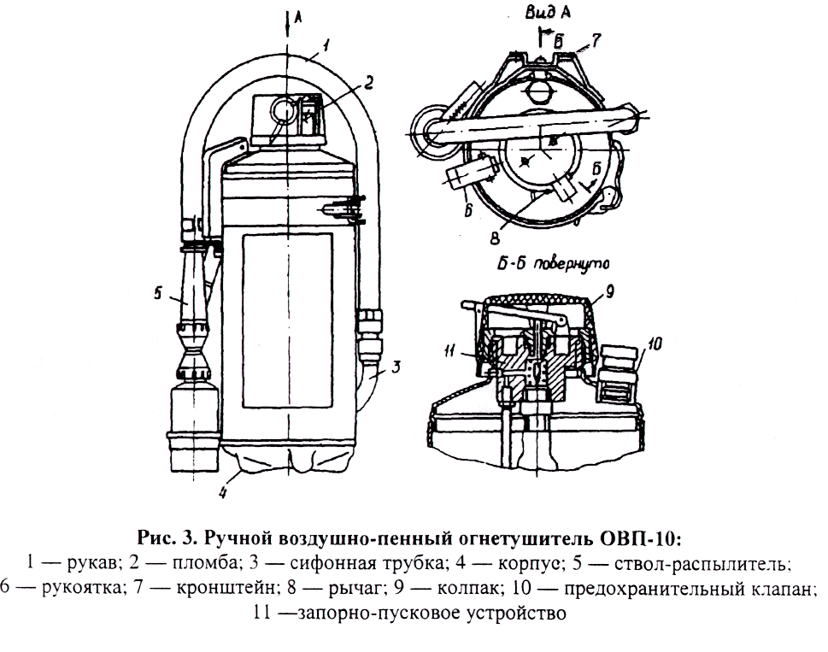
View A
Б-Б turned
Fig. 1 Manual air-foam extinguisher OVP-10:
1 – hose; 2 – seal; 3 – siphon tube; 4 – casing; 5 – diffuser branch;
6 – handle; 7 – mount; 8 – lever; 9 – cover; 10 – safety valve;
11 – lock and release device

ANNEX 2

Gas extinguishers

Gas extinguishers use non-flammable gases as extinguishing agents (carbon dioxide) or halogenated hydrocarbons (bromoethyl, FM200).
Depending on the type of extinguishing agent, these extinguishers are called carbon dioxide, FM200, bromoethyl-FM200, etc)
Carbon dioxide extinguishers (CDEs) are widely spread due to their versatility, compact design and effectiveness.
Carbon dioxide extinguishers may be of manual type (OU-2, OU-5 and OU-8), wheeled (OU-25 and ОУ-80) and transportable (ОУ-400).

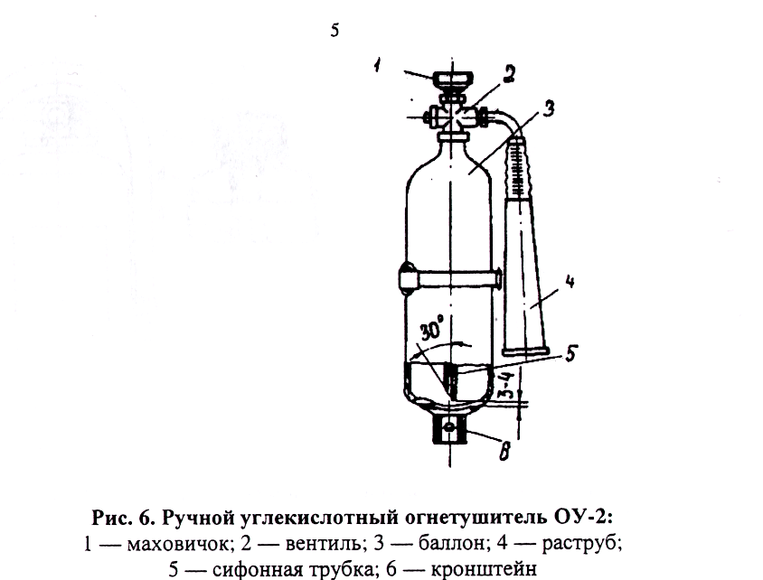
Fig. 6 Manual carbon dioxide extinguisher OU-2:
1 – flywheel; 2 – globe valve; 3 – bottle; 4 – discharge horn:
5 – siphon tube; 6 – mount

To activate the manual carbon dioxide extinguishers ОУ-2, ОУ-5 and ОУ-8:
using the transport handle, remove and bring the fire extinguisher to the fire site; direct the discharge horn at the combustion scene and open the lock and release device (globe valve or lever).
Lock and release device allows to intermit the carbon dioxide discharge.
During operating of all types of CDEs it is prohibited to hold the discharge horn with a bare hand, for upon exiting carbon dioxide turns into a snow-like mass with temperature of minus 80 °С.
Do not place the CDEs near heaters, where the temperature can be over 50 °C, also direct exposure of bottles to sunlight should be avoided

ANNEX 3

Dry powder extinguishers

Dry powder extinguishers (DPEs) are designed to extinguish fires of solid, liquid and gaseous substances (depending on the brand of the extinguishing powder used), as well as electrical installations under voltage up to 1 kV (1000 V).

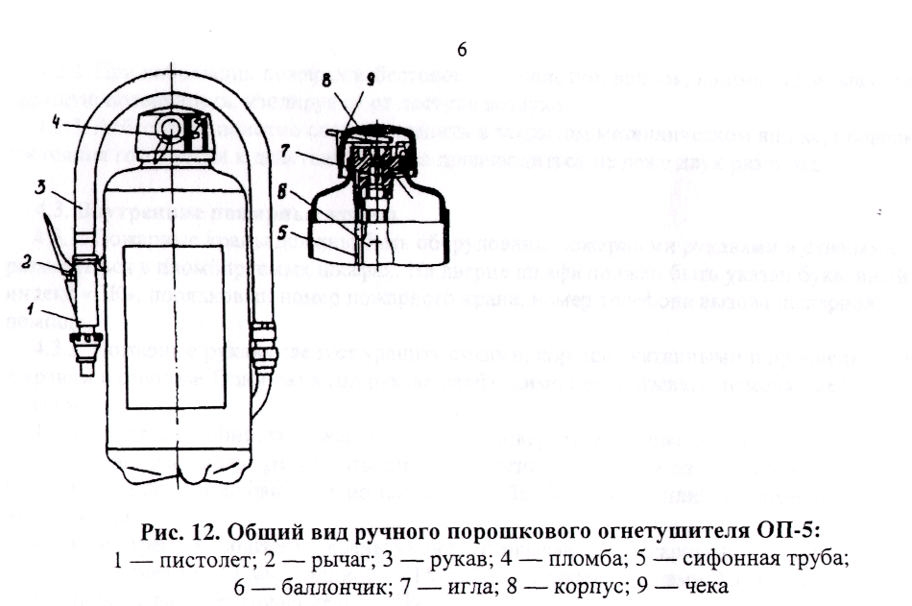
Fig. 12 View of the manual dry powder extinguisher OP-5:
1 – gun; 2 – lever; 3 – hose; 4 – seal; 5 – siphon tube;
6 – bottle; 7 – needle; 8 – casing; 9 – lock pin
Manual dry powder fire extinguishers are manufactured with charge masses of 1; 2; 5 and 10 kg, wheeled – 50 and 100 kg, stationary automatic fire extinguishers (Fig. 14) – 50 and 100 kg.
To activate the manual powder extinguishers OP-2, OP-5 (see Fig. 12) or OP-10, it is necessary to bring the fire extinguisher to the fire scene, pull out the wedge or lock pin 9, push the lever 2 and direct the powder spray into the fire. Lowering the lever will be enough to stop the powder spray.
Multiply use and intermittent operation are allowed.
Extinguisher shall be kept strictly vertical, without turning it over during operation.
It is prohibited to dismantle extinguishers under pressure to lower its internal pressure level.

ANNEX 4

Backpack forest extinguishers

Backpack extinguishers are designed for extinguishing creeping forest fires with water and water solutions of non-harsh chemicals. They are used for direct extinguishing of fire in case if there is an opportunity to get close to the fire scene, and in case if there is a water body nearby. Extinguisher is used for direct extinguishing or for creating fire lines with chemical solution spill. 0.5 to 1 liter of chemical solution per 1 m² of surface is required to create a stable barrier, depending on the types of vegetation cover and site clutter. OC-5 multi-purpose fire extinguishing composition of high fire-extinguishing properties and fire-retardant ability is used as the main chemical.
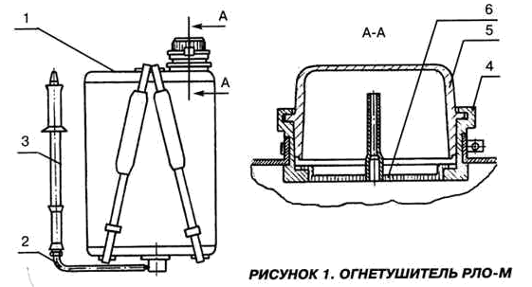
FIGURE 1, EXTINGUISHER RLO-M

RLO-M extinguisher as per the figure consists of the following main parts: a bag for the forest fire extinguisher (1) and a manual hydro-cannon pump (3) attached to the bag with a rubber tube (hose) (2).
The bag (1) is made of rubberized cloth. There is a neck opening (4) in the upper part equipped with filter (6) and protected by cover (5). The latter is made as a 0.35 liter cup. The bag has adjustable straps for carrying it on the back.

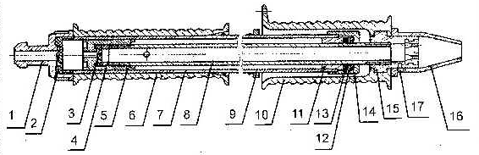
FIGURE 2. HYDRO-CANNON

Hydro-cannon is a manual piston-type double-displacement pump consisting of a cylinder (7) with a handle (6) and thrust rod (8). From the handle side, a fitting (1) with a valve (2) is screwed on the cylinder. Another end of the cylinder ends with a bush bearing (11), with a seal (13) that has a closure ring (12) inserted in its spot facing. Seal closure is done by a nut (14).
Thrust rod has a piston (5) with a valve (3) screwed on it from the side with two cross-bores. To prevent the valve from deforming upon fitting of a piston, a bushing (4) is installed on the thrust rod between the valve and the thrust rod. At the other end of the rod, a spray handle (10) is screwed on, and a cap (16) fixed with a screw (17), is put on the tip (15). The cap serves to adjust distance and width of the spray
Extinguisher is charged through a neck opening. In order to do that, the backpack should be put on the ground, and the cover removed. If necessary filling the bag with water can be done with the cover of the extinguisher (when recharging the extinguisher from a shallow source – a puddle or stream). After the backpack if recharged, neck opening shall be closed with cover.
Before strapping the backpack the straps shall be adjusted as per the worker’s height.
Hydro-cannon is activated by reciprocating movement of the rod relative to the cylinder.
To prevent leakage of liquid when carrying a charged fire extinguisher, the hydro-cannon thrust rod shall be fully lowered, and the hydro-cannon itself fastened to a special clasp on the right shoulder strap.
As per the customer requirement, RLO-M extinguisher can be equipped with a foam-generating nozzle РЛО-М.02.000
Foam-generating nozzle is applied for extinguishing fires of class B (liquids combustion).

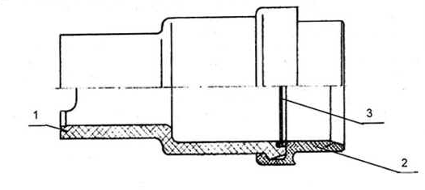
FIGURE 3. FOAM-GENERATING NOZZLE
Foam-generating nozzle comprises casing (1) discharge jet (2) and a net molded into a polyethylene ring (3).
Foam-generating nozzle application:
- put the nozzle on the cap (Figure 2, pos. 16) of the hydro-cannon, aligning the groove in the cap (under the screw) with the groove of the nozzle;
- pour 16.9 liters of water in the extinguisher bag and add 1.1 liters (four measures of RLO-M cover, pos. 5 in Fig. 1) of foaming agent (of any brand: PO-1D, PO-ZAI, PO6K, PO-“TEAS”, PO-“SAMPO”, PO-Foretol, PO – multipurpose – depending on the types of burning materials);
- when operating a water cannon with a foam-generating nozzle, the release range of the foam is regulated by turning the nozzle together with the cap. Angle of the nozzle rotation is limited by the groove in the cap.

ACKNOWLEDGEMENT LIST
for Instructions on safety measures during taking actions
aimed at prevention of spread of forest fires
No. 10100-03-15
________________________________________________________________________________
(name of the unit)

Item No.  No. | Position  (occupation) | Initials, surname | Date | Signature

DOCUMENT REVISION SHEET
for the Instructions on safety measures for taking actions aimed at prevention of spread of forest fires

No. 10100-03-15

Number  of the amendment | Name, date, number  of the administrative document | Pages with  the amendments | List  of the amended  paragraphs

