Annex
to the Order dated __________________________


Branch
in Ust-Ilimsk

Р 04.01-07-17

R E G U L A T I O N

Scaffolds.
Configuration, acceptance, disassembly

To replace: Р 04.01-07-12

Introduced by: order dated ____________________

Introduction date: ______________________

TABLE OF CONTENTS

1 Purpose 3
2 Scope 3
3 Terms and definitions. Abbreviations and symbols 3
4 General provisions 4
5 Configuration of scaffolds 5
6 Acceptance of the scaffolds into exploitation 7
7 Scaffolds exploitation 9
8 Disassembling of scaffolds 10
9 Scaffolds storage 11
10 Responsibility 11
Annex A (mandatory) Instruction on the assembly and use of scaffolds (scaffolding system Layher Allround with the cottering) 12
Annex B (mandatory) PASS on the scaffolding system Layher Allround with the cottering 12
Annex C (mandatory) Form of the Project for the production and assembly of the non-standard scaffolds 13
Annex D (mandatory) Log-book form of applications on the assembling and disassembling of scaffolds 19
Annex E (mandatory) Form of red signal tablet 20
Annex F (mandatory) Form of the Log-book of reception and examination of the scaffolds and scaffolding platforms 21
Annex G (mandatory) Form of the Act of acceptance of scaffolds into exploitation 22
Annex I (mandatory) Form of green signal tablet 23
Annex J (mandatory)Form of acts for the configuration and disassembly of scaffolds (scaffolding platforms) 24
Annex K (mandatory) The form of the Act for coordinating the placement of materials and equipment in the workshop area 25
Document revision sheet 27

1 PURPOSE

This Regulation determines the procedure for the configuration, acceptance, disassembly of scaffolds during the works at permanent facilities of the Branch of JSC Ilim Group in Ust-Ilimsk (hereinafter – Branch).

2 SCOPE

2.1 This Regulation is obligatory for execution by heads and specialists of the Branch subdivisions and contractor organizations.
2.2 Requirements of this Provision are brought to notice to the contract organizations which perform the activity in the territory of Branch, during concluding the contracts, by issuing of the normative documents established by the List of requirements of production safety, for familiarization of workers of the contractor (subcontractors of the contractor) and inclusion in texts of the relevant contracts of duties of contractors, performers, etc. on ensuring compliance with the present Regulation.

3 TERMS AND DEFINITIONS. ABBREVIATIONS AND SYMBOLS

The Regulation contains the following terms and definitions:
Customer is the head of the structural subdivision of the branch or an official of the contract organization authorized to represent interests during the preparation and signing of Applications for the configuration and disassembling of scaffolds.
Standard scaffolds – temporary building construction, which has a manufacturer's passport with an indication of calculated indicators of technical and technical and economic characteristics.
Scaffolds – a multi-tiered construction designed to organize workplaces on different horizons.
Deck is a structural element that is installed on the supporting constructions of the building (walls, collars, beams, girders) or the constructions of scaffolding means for works.
Non-standard scaffolds – scaffolds, which are installed in the places of workplaces as appointed by the Customer, are built according to the “Project for the production of works for the manufacture and assembly (disassembly) of non-standard scaffolds”.
Scaffolding platforms is a single-staged construction designed for performing works that require the movement of workplaces along the front of the works.
The head of the scaffolds installation and disassembly is a representative of the contractor organization, who guides the installation and disassembly of the scaffolds.
The head of the scaffolds exploitation is a worker of the contractor organization or branch structural subdivision, who guides the works with the use of scaffolds.
The head of the structural unit is a worker who holds the position of the head or the deputy head of the branch structural subdivision.
Signal tablet is a tablet of red or green color, which is placed in the places of climbing on the scaffolds and informs about the working or not working state of the scaffolds at a given time moment.
Signal tablet of green color – a tablet placed on the scaffolds after the acceptance of the scaffolds into exploitation (work on the scaffolds is permitted).
Signal tablet of red color – a tablet placed on the scaffolds during the process of their installation (the scaffolds are not ready for exploitation); works on the scaffolds installation are completed, but no repairs are performed from them; in the design of scaffolds were revealed the violations of security requirements.
The specialist on labor protection of organization for the installation and disassembling of scaffolds – contractor worker, trained and certified for labor protection, familiar with this Regulation.
OSH specialist on labor protection of the Branch –the worker of the Branch of JSC Ilim Group, trained and certified for labor protection, familiar with this Regulation.
Scaffolding means – devices designed to organize workplaces during the construction and installation works at the height or depth of more than 1.3 m from the ground level or overlap.
OSH – Occupational Safety and Health Department
MS – the method statement on installing and disassembling of wooden non-standard scaffolds.
FS ER Service stands for fire safety and emergency response service.

4 GENERAL PROVISIONS

4.1 Planning, execution and acceptance of works on assembling and disassembling of forests is performed under terms of the agreement concluded between the Branch and the contractor organization, which installs the scaffolds at the direction of Customer.
4.2 Non-standard wooden and standard metal scaffolds are installed under terms of the agreement.
4.3 All works on installation, disassembly and exploitation of scaffolds should be carried out in accordance with the rules on labor protection during the overhead works (Order No. 155n from 28.03.2014) in accordance with:
a) instructions for the assembly and exploitation of the scaffolds (Annex A), manufacturer's certificates (Annex B) – for metal standard scaffolds;
b) the method statement on installing and disassembling of wooden non-standard scaffolds (Annex C).
4.4 Assembly and disassembly of scaffolds is performed according to safe work permit.
4.5 The impregnation of combustible structures with flame retardants or the use of non-combustible standard scaffolds shall be provided during the constructing of wooden scaffolding means.
4.6 Scaffolding means up to 4 meters are installed:
a) with the support of the contracting organization, if the manufacturer of the works using scaffolds are the workers of contractor organization;
b) by the head of the installation and disassembling of scaffolds, if the manufacturer of works using scaffolds are workers of the Branch.
4.7 The signal tablets should be placed on the scaffolds.

5 CONFIGURATION OF SCAFFOLDS

5.1 Before the commencement of works the Customer:
1) determines, forms, signs the list of persons who are authorized to submit applications for the installation and disassembling of scaffolds and passes it to the head of the contractor organization for the installation and disassembling of scaffolds;
2) makes an application for the installation/disassembling of scaffolds in the “Log-book of applications for the installation and disassembling of scaffolds” (Annex D). On the configuration of wooden scaffolds with a height of more than 4 m, the MS number or name is indicated in the “Log-book...”
5.2 “The log-book of applications for the installation and disassembling of the scaffolds” is stored on a site in a contractor organization that performs works on the installation and disassembling of scaffolds. The persons responsible for maintaining and storing of this Log-book should be appointed in the contracting organization.
5.3 The requirements to the execution of the method statement on installing and disassembling of wooden non-standard scaffolds
5.3.1 Development, coordination, approval:
Item No. | Scaffolds customer | Method Statement  on installing and disassembling of wooden non-standard scaffolds
Item No. | Scaffolds customer | develops | coordinates | approves
1 | Branch | Manager | worker on occupational safety | technical supervisor
1 | Branch | of contractor organization, which performs works on the installation and disassembling of scaffolds
2 | Scaffolds for emergency response, Customer – Branch | Manager | worker on occupational safety | Head of subdivision of the Branch – customer of scaffolds
2 | Scaffolds for emergency response, Customer – Branch | of contractor organization, which performs works on the installation and disassembling of scaffolds |  | Head of subdivision of the Branch – customer of scaffolds
3 | Contractor organization during the performing of works at the Customer's facilities | Manager | worker on occupational safety | technical supervisor
3 |  | of contractor organization, which performs works on the installation and disassembling of scaffolds
5.3.2 The last sheet in the MS (Annex C) is filled in:
1) By the Customer, with specification:
а) of the object, where the scaffolds are installed (building, workshop);
b) of place of scaffolds installation (axis, mark);
c) of scaffolds height;
d) of load on the scaffolds.
2) The head on installing and disassembling of scaffolds with specification:
а) of scaffolds construction;
б) of front length;
c) of the width of the working deck;
d) of the interval between the deck floors;
e) distance between the legs across the front, m;
f) distance between the legs across the width, m;
g) the front length, m;
h) number of deck floors.
5.4 The head of the installation and disassembling of the scaffolds invites the Customer's representative to determine the dimensions, type of scaffolds and coordinates the implementation of the declared scaffolds.
5.5 The customer should prepare a place for the scaffolds installation, namely: to remove the foreign objects that interfere with the installation and disassembling of scaffolds.
5.6 The head of works on installation and disassembling of the scaffolds:
1) performs the installation of the scaffolds coordinated with the Customer, according to the application made in the “Log-book...”;
2) before the end of the work, makes and places an alarm red tablet on the scaffolds (Annex E).

6 ACCEPTANCE OF THE SCAFFOLDS INTO EXPLOITATION

6.1 The scaffolds and scaffolding platforms up to 4 m in height are allowed to be used after their delivery and acceptance by the head of the works on scaffolds exploitation at the head of the works on installation and disassembling of the scaffolds, with the appropriate record in the “Log-book of reception and examination of the scaffolds and scaffolding platforms” (Annex F).
6.1.1 The head of the structural unit determines by his/her order:
a) the responsible persons (chiefs of shifts, shift foremen, the mechanic, the power engineer, etc.) for maintaining and storage of the “Log-book of reception and examination of the scaffolds and scaffolding platforms”;
b) the place of storage of “Log-book of reception and examination of the scaffolds and scaffolding platforms” (in chiefs of shifts, shift foremen, on the control panel, etc.).
6.2 The acceptance of the scaffolds higher than 4 m, is made by the commission, organized head of works on installation and disassembling of the scaffolds
6.2.1 The commission includes:
- the head of works on scaffolds exploitation;
- the head of works on installation and disassembling of the scaffolds;
- the head of subdivision;
- specialist for labor protection (organization of the manufacturer of works using scaffolds);
- specialist of the FS ER Service (in case of acceptance of wooden scaffolds).
6.2.2 In the case of performing works using the scaffolds by the contractor's staff in the Customer's territory, the commission composition (for each specific case) shall be determined by the head of works on installation and disassembling of the scaffolds.
6.2.3 According to the results on delivery and acceptance of scaffolds into exploitation the head of works on installation and disassembling of the scaffolds:
1) issues the “Acceptance certificate of Scaffolds into Exploitation” (Annex G).
“Acceptance certificate...” is signed by the members of the commission, is confirmed by the chief engineer according to his/her affiliation to the unit. It is allowed the adoption of the “Acceptance certificate of Scaffolds into Exploitation”, constructed by contract organization for its needs, by the supervising foreman of this organization .
2) in case of defects reveal organizes their immediate elimination. “Acceptance certificate …” in this case is not signed until the elimination of the mentioned defects. During the period before the signing of the “Acceptance certificate...” the exploitation of the scaffolds is prohibited (the red tablet is placed);
3) passes the signed “Acceptance certificate of Scaffolds into Exploitation” to the head of works on scaffolds exploitation.
6.2.4 When accepting the scaffolds established for emergency response operations:
6.2.4.1 The head of works on installation and disassembling of the scaffolds:
1) issues the “Acceptance certificate of Scaffolds into Exploitation”, which is signed by:
а) the head of works on scaffolds exploitation, the head of the structural unit on which territory (equipment) the works will be done;
b) the head of works on installation and disassembling of the scaffolds.
2) in case of defects reveal organizes their immediate elimination. “Acceptance certificate …” in this case is not signed until the elimination of the mentioned defects. During the period before the signing of the “Acceptance certificate...” the exploitation of the scaffolds is prohibited (the red tablet is placed);
3) passes the signed “Acceptance certificate of Scaffolds into Exploitation” to the head of works on scaffolds exploitation.
6.2.5 The head of works on scaffolds exploitation, according to the “Acceptance certificate of Scaffolds into Exploitation” makes a record into the “Log-book of reception and examination of the scaffolds and scaffolding platforms”.
6.3 After the signing up of the Acceptance certificate of scaffolds into exploitation the head of works on installation and disassembling of the scaffolds:
1) replaces the red signal tablet on the green signal tablet (Annex I);
2) in the “Log-book of reception and examination of the scaffolds and scaffolding platforms” fills the column 5 with indication of the date of the signal green tablet installation, full name of the person who installed a green tablet.

7 SCAFFOLDS EXPLOITATION

7.1 In the case of location of scaffolds on the street, before the start of the shift, the deck should be cleaned of snow and ice.
7.2 After the end of the shift the deck should be cleaned of debris and residues of construction materials.
7.3 The scaffolds (scaffolding platforms) in the exploitation process are examined by the head of works on scaffolds exploitation:
а) daily – before the start of works;
b) periodically, but not less than once in 10 days – with the registration of the record in the “Log-book of reception and examination of the scaffolds and scaffolding platforms” (Annex F).
7.4 During the examination is checked the following:
а) strength and reliability of fastenings, decking, fencing, fixing devices, which protect umbilical connections from spontaneous disconnection,
b) the state of welded seams, deflections of stands and collar beams.
c) absence of foreign objects, snow, ice.
7.5 In the case of mechanical impact on the scaffolds design or the violation of their integrity:
7.5.1 The head of works on scaffolds exploitation:
1) immediately stops the works;
2) reports the presence of defects in structural elements to the head of works on installation and disassembling of scaffolds.
7.5.2 The head of works on installation and disassembling of the scaffolds:
1) replaces the green signal tablet with a red signal tablet (the scaffolds are not ready for exploitation) with a record in the “Log-book of reception and examination of the scaffolds and scaffolding platforms” (in column 7 “special notes” is made a note about the placing of the red signal tablet with the date of its placing, the full name of the person who installed the red signal tablet, the reasons for installing of the red signal tablet);
2) organizes the immediate elimination of defects in structural elements;
3) performs the procedure in accordance with clause 6.2 and clause 6.3 of this Regulation.
7.6 In the case of works using scaffolds alternately by several contract organizations:
7.6.1 The head of works on scaffolds exploitation informs the head of the works on installation and disassembling of the scaffolds at the end of the works.
7.6.2 The head of works on installation and disassembling of the scaffolds replaces the green signal tablet with a red signal tablet with a record in the “Log-book of reception and examination of the scaffolds and scaffolding platforms” (in column 7 “special notes”).
7.6.3. For the admission to the works of the next contractor is made a procedure in accordance with the clauses 6.2 and 6.3 of this Regulation.
7.7 If the scaffolds higher than 4 m were not used during the month and longer:
7.7.1 The head of the structural unit informs about presence of such scaffolds the head of works on assembling and disassembling of scaffolds.
7.7.2 The head of works on installation and disassembling of the scaffolds, in case of necessity of works performance using these scaffolds, performs actions in accordance with Section 6 of this Regulation.
7.7 The head of works on scaffolds exploitation is strictly forbidden to independently make any changes to the design of scaffolds that are not provided for in the “Instruction on the design and use of scaffolds” or MS during the use of wooden non-standard scaffolds.
7.8 In case of reveal the violations of the scaffolds design during their exploitation, an OSH specialist or FS ER Service specialist acts according to the clause 7.5.2.

8 DISASSEMBLING OF SCAFFOLDS

8.1 The Customer of scaffolds after completing all the works using scaffolds makes an application during the 24 hours to the head of works on installation and disassembling of scaffolds in the form of a record in the “Log-book of applications for the installation and disassembling of scaffolds” for disassembling of scaffolds.
8.2 The head of works on installation and disassembling of scaffolds replaces the green signal tablet with a red signal tablet with a record in the Log-book of reception and examination of the scaffolds and scaffolding platforms (in column 7 “special notes” is made a note about the placing of the red signal tablet with the date of its placing, the full name of the person who installed the tablet, the reasons for installing of the signal tablet).
8.3 After the scaffolds disassembly is completed an “Act on installation and disassembling of scaffolds” (Annex K) by the bilateral signing of the parties the Section 2. “On scaffolds disassembling”.
8.4 The contractor organization that installs the scaffolds higher than 4 m (scaffolding platforms) by its own efforts, performs disassembling and removal of the disassembled scaffolds within 10 days after completion of works, in accordance with the requirements of Regulation 05.01-01-16 “Waste Management”.
8.5 The head of works on installation and disassembling of the scaffolds:
1) disassembles the wooden non-standard scaffolds and removes them in accordance with the requirements of Regulation 05.01-01-16 “Waste Management”.
2) disassembles the metal standard scaffolds and removes them to the place of their permanent storage (storehouse);
3) in the “Log-book of applications for the installation and disassembling of scaffolds” makes a record of the fact of the scaffolds disassembling;
4) on the basis of the agreed volumes and the Standard norms approved by the Maintenance Manager of the Branch, for the wooden non-standard scaffolds, the Act of the executed works of the KS-2 form for the device and disassembling of scaffolds over 4 meters is prepared with the indication:
a) name of the performed work;
b) the inventory number of the basic mean on which the works were carried out.
8.6 The works for payment are accepted after the complete disassembly of the scaffolds on the basis of the Act of Completed Works with the completed and signed by the parties Annex of the Sections “1. On configuration of scaffolds” and “2. On scaffolds disassembling”.

9 SCAFFOLDS STORAGE

9.1 During the periods between exploitations is organized the storage of scaffolds. The details of the scaffolds are stored in the assorted form (stands, collar beams, braces, frames) in containers and packages. Small parts (anchors, branch pipes, collar clamps, etc.) are stored separately in a container.
9.2 The scaffolds should be stored indoors or under a shelter on the gaskets that do not touch the ground.
9.3 The head of works on installation and disassembling of the scaffolds:
1) obligatory coordinates the place of temporary storage of scaffolds elements (for the period of installation and disassembling) in the workshop with the making of the “Act for the coordination of the placement of materials and equipment on the territory of the workshop” (Annex L). The act should be obligatory coordinated by the head of the structural unit (the workshop manager) and the representative of the fire safety and emergency services.
2) is obliged at the place of temporary storage of scaffolds elements to place the copy of the “Act of agreement on the coordination of placement of materials and equipment on the premises of the workshop” agreed by all interested parties.
9.4 Containers, packages and boxes may be stacked, but not more than in three tiers.

10 RESPONSIBILITY

Managers and specialists which are prescribed by the Regulations to perform activities shall be responsible for non-fulfillment and/or their improper fulfillment.

Maintenance Manager | Signature | A.V. Belov
Acting as Chief Construction Engineer | Signature | D.V. Ladygin

Annex A
(mandatory)

Instruction on the assembly and use of scaffolds
(scaffolding system Layher Allround with the cottering)

The instruction is posted for public access on V:\General programs and documents\ISM documents\Organizational documents SPF\04.01-07-17.

Annex B
(mandatory)

CERTIFICATE

on the scaffolding system Layher Allround with the cottering

The certificate is posted for public access on V:\General programs and documents\ISM documents\Organizational documents SPF\04.01-07-17.

Annex C
(mandatory)

Form of the Project for the production and assembly of the non-standard scaffolds

AGREED BY  ________________________  ________________________  “____”____________20___. | APPROVED BY  ________________________  ________________________  “____”____________20___.
METHOD STATEMENT
on production and assembly of the non-standard scaffolds

Annex C
(continues)

Safety rules for the installation of wooden scaffolds and scaffolding platforms  1. Scaffolds and scaffolding platforms shall conform to the SNiP requirements 12-03-2001. “Construction safety requirements” cl. 7.4 “Scaffolding means”.  2. Wooden scaffolds and scaffolding platforms are made of dry soft or hard wood not lower than the 2nd grade according to GOST 8486-86.  3. The scaffolds shall be equipped with ladders or entrance ramps secured thereto which provides for the workers’ safe entrance to and coming off the scaffolds.  4. To ensure stability, the scaffolds stands should be attached to the strong places of the building or constructions throughout the entire height.  4.1. The places and methods of stands fastening are indicated by the master in coordination with the department of the chief builder and the workshop manager.  4.2 In case of absence of instructions concerning the fastening of scaffolding means in the method statement, the scaffolds shall be fixed to the walls of buildings (facilities) not less than in every other layer for edge racks, in every two spans for the upper layer and one fastening per each 50 square meters of the scaffolds surface projection on the facade of the building (facility).  4.3 It is not allowed to fasten the scaffolding means to the parapets, cornices, balconies and other projecting parts of buildings and constructions, to operating equipment, to technological communications.  5. The scaffolds shall be designed to carry maximum load with the safety coefficient not less than 4.  5.1 The impact of loads on the scaffolding means during the works should not exceed the estimated loads specified in the method statement. If any additional loads are required to be made on the scaffolds and scaffolding platforms (caused by materials hoisting machinery, load-lifting platforms, etc.) the construction thereof should be checked for these loads.  5.2 The mass gathering of people on decks in one place is not allowed.  5.3 The decks on the scaffolds and scaffolding platforms should have an even surface with no more than 5 mm clearance between elements and should be fastened to the scaffolds cross bars. The ends of the abutting elements of the decks shall be placed on the supports and should be overcovered not less than 20 cm each way.  6. Width of decks on scaffolds and scaffolding platforms should be: not less than 2 m for masonry works, 1.5 m for plastering, 1 m for painting and installation works.  7. When placing the deck elements (panels, wood boards) on the supports (fingers, girders) one should check their holding power and make sure that such elements can not be moved.  8. Poles, frames, supporting ladders and other vertical deck members shall be installed and braced with bracings according to the method statement. Supporting risers shall be securely strengthened from shattering with braces and struts.  9. A single (unsplit) board pad not less than 5 cm thick shall be placed edgeways under the ends of each pair of scaffolding poles. Supporting pads shall be placed on the preliminarily planned and puddled surface.  It is not allowed to make the pad even with the use of bricks, stones, board and wedge chips. | 10. When performing works using the scaffolds with a height of 6 m or more, there should be at least two decks: working (upper) and protective (lower). No works in several layers on one vertical without intermediate protective decks between them shall be permissible.  11. In cases where the performance of works, movement of people or transport under the scaffolds and near them is not provided, the device of protective (lower) deck is not necessary.  12. The scaffolds shall be equipped with the ladders or traps for ascending and descending of personnel located at no more than 40 m from each other. The upper end of the ladder or trap shall be fastened with the scaffolding bearers.  13. Openings in the scaffolding decks to exit from ladders shall be fenced. Pitch of ladders must be not more than 60 degrees to the horizontal surface. The trap pitch should not exceed 1:3.14. To lift the load to scaffolds one shall use blocks, jibs and other labor saving tools to be fastened according to the method statement. Openings for moving of loads should have four-sided railings.  15. Near the driveways the scaffolding means should be installed at a distance of at least 0.6 m from the vehicle's overall dimensions.  16. The scaffolds with a height of more than 4 m are allowed to be used after delivery and acceptance by the commission with the issuing of the certificate. Before approval of the certificate the work using the scaffolds is not allowed.  17. When accepting the scaffolds and scaffolding platforms shall be checked the following: ties and fastenings ensuring stability, strength of fastener assemblies of certain members; serviceability of working decks and railings; vertical position of poles; security of base platforms.  18. The scaffolds not used for works within a month or more shall be repeatedly accepted before resumption of works.  19. In order to avoid impacts on the scaffolds by the cargo suspended to the crane hook, the turn of the crane's boom simultaneously with the lifting (descent) of the cargo in the immediate vicinity of the scaffolds is not allowed. Cargo lifting and lowering onto the deck should be performed at the minimum speed, smoothly, without jolting.  20. The gap between the building wall or the equipment and the working deck of the scaffolds installed near them should not exceed 50 mm for masonry and 150 mm for finishing works. During performing of thermal insulation works, the gap between the insulated surface and the working deck must not exceed twice the insulation thickness plus 50 mm. The clearances greater than 50 mm in all cases when work is not done, should be closed.  21. The assembly and disassembly of scaffolds are carried out in accordance with the sequence provided by the MS. The workers involved in the assembly and disassembly of scaffolds should be instructed on the methods and sequence of work and safety measures.  22. The access for unauthorized persons to the area where scaffolds and scaffolding platforms are installed or disassembled should be closed.

Annex C
(continues)
Fire-Fighting Measures  1. The construction of scaffolds and scaffolding platforms during construction and repair should be carried out in accordance with the requirements of design standards for fire safety, required to the evacuation routes.  2. Managers, specialists, employees and workers involved in organizing, coordinating and conducting of fire operations, should be familiar with the instruction on fire safety measures during welding and other fire works at the facilities of the Branch of JSC Ilim Group in Ust-Ilimsk (И 05.03-03-15).  3. The scaffolds have to be equipped with a ladder or a step-ladder.  4. The scaffolds and scaffolding platforms should be periodically cleaned from construction debris, snow, ice, and, if necessary, to be sanded.  5. The scaffolding structures should be closed (made coldproof) with combustible materials (plywood, plastics, slabs, tarpaulin, etc.) IT IS PROHIBITED:  6. If it is necessary to install scaffolds and scaffolding platforms near the hot surfaces and equipment elements, the wooden parts of scaffolds and scaffolding platforms should be protected from fire with non-combustible material.  7. When conducting fire works using scaffolds, the place should be equipped with primary fire extinguishment means.  8. After disassembling of the scaffolds construction, the boards and stands should be removed from the territory of the workshop.  Non-standard ready-made scaffolds  Executive Summary  The scaffolds are intended for the production of external, internal works on brickwork, painting, heat-insulating, installation and other works.  The scaffolds construction provides the possibility of installing an interval between the tiers of decks from 800 till 2400 mm with a step of 400 mm and changes in the distance between the scaffolds stands along the front of the wall from 1155 till 2655 m with the step of 0.5 m.  During installation, the step of scaffolds stands is established depending on the need for an allowed evenly distributed load per 1 m² of the deck and is determined according to Table 1  At installation of the scaffolds in connection with the provided instruction the height of scaffolds assembly can reach 25 m (4 tiers of stands).  At application of containers weighing 1 ton on the 240 bricks a limit step of stands in installation sites of containers shouldn't exceed 1555 m distance between the containers weighing 1 ton on axes; on the front of wall there shouldn't be less than 20.8 m. | The construction of scaffolds and the technology of assembly – disassembly  The scaffolds are constructed of 7 wooden elements: Stand, ledger boards, pitch boards fences, guard boards, landing boards, ribbed-slab fillers, ladders.  1. Stand – the last bars have a section of 55x150 mm. Each intermediate bar is nailed to each bar by 4 nails.  2. Ledger board – consists of a board with a section of 150x40 L = 3250 mm.  3. Pitch boards fence – consists of a board with a section 25x150 mm, fastened to the stands and among themselves in the center by the nails.  4. Guard board – with a section of 150x25 mm and is fastened to the stands by the nails.  5. Landing board – is made from a board with a section of 50x150 mm in place, fastened together by the wooden planks of 25x120 mm.  6. Ribbed-slab fillers – 680х260х50 mm  7. Ladder – consists of a board with a section of 40x150 mm, the fencing of the ladder with a section of the board of 25x150 mm, step of the steps – 0.3-0.4 m; the width of the ladder is not less than 0.8 m.  The stands are connected with each other in pairs by the ledger boards, put in between the bars of stands at the required height. In the housings formed between the bars of stands over the crossbeams are inserted the ledger boards with their edges, thus connecting stands, cross bars and ledger boards into one rigid spatial system.  The additional stiffness in the longitudinal and transverse direction is provided by the installation of the pitch boards.  The landing boards are laid along the ledger boards, forming a dense deck. When installing the 2nd and the next tier of the scaffolds, the joints of the stands are made by the turning to 180 degrees around the vertical axis, after which the ends of the stands are tightly connected to each other, forming a rigid joint.  The fencing boards are laid between the bars of the stands on the component heights of the railing. The height of the fencing should be not less than 1.1 m, the board element – not less than 0.15 m, the distance between the horizontal elements of the fencing guard – not more than 0.5 m.  Table 1  The main characteristic of the elements  A general view of the assembled scaffolds section is shown on the page 5.  The working drawing of the stand and the joint detail of the stand links are shown on the page 4.
  Item No. | Allowed evenly distributed load per 1 m² of the deck. | The distance between the stands
  1 | 150 | 2655
  2 | 200 | 2156
  3 | 250 | 1555
  4. | 400 | 1155
  Item No. | Name and size of elements | Volume, m³ | Weight, kg
  1 | Stand 6500х260х155 | 0.015 | 42
  2 | Ledger board 2500х150х40 | 0.015 | 8
  3 | Longitudinal, transverse pitch boards and fence boards 150х25
  4. | Guard board 2950х150х25 | 0.012 | 7
  5. | Landing board in place from the board 150х50
  6. | Ribbed-slab filler – 680х260х50 | 0.03 | 2
  7 | Ladder 3000х650х110 | 0.032 | 16
  8 | Wall mounting assembly 335х115
  9 | Nails

Annex C
(continues)

The overall view of the stand  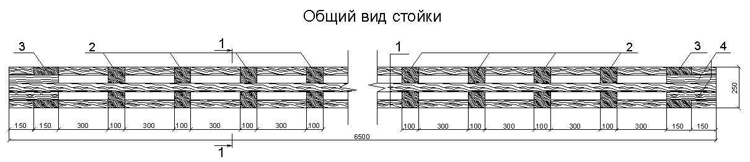 | 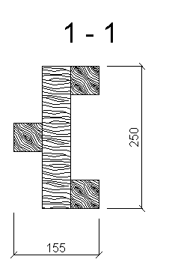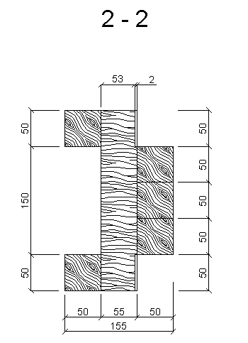
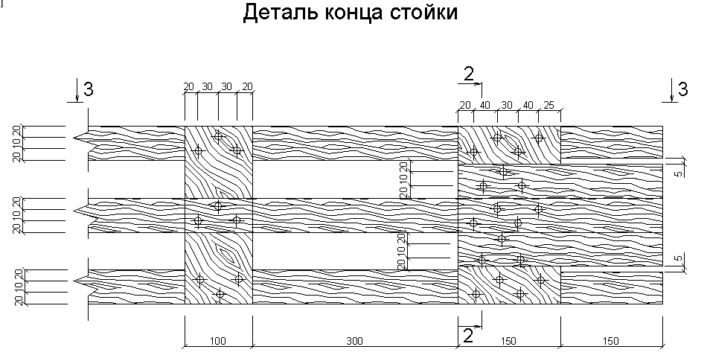  Stand end detail | 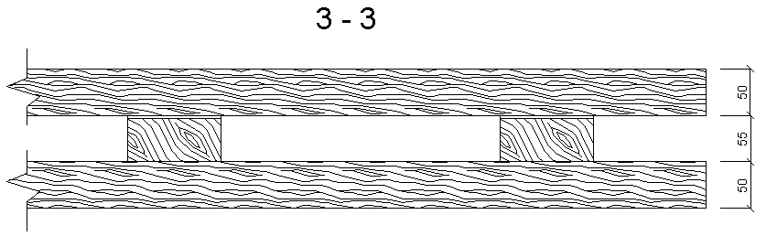

Annex C
(continues)
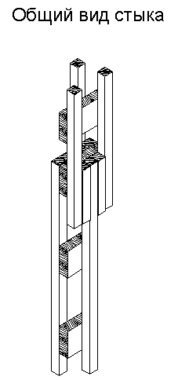  The overall view of the joint | 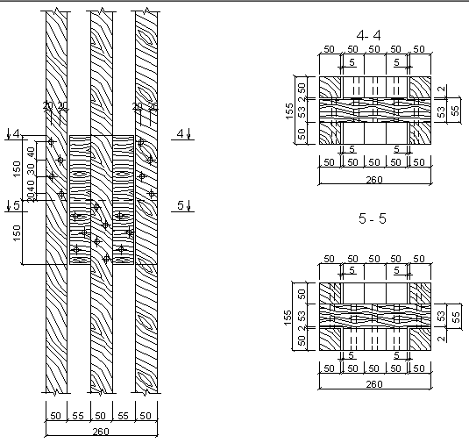

Annex C
(continues)
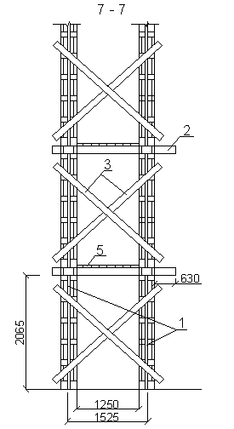 | 8  Front elevation fragment  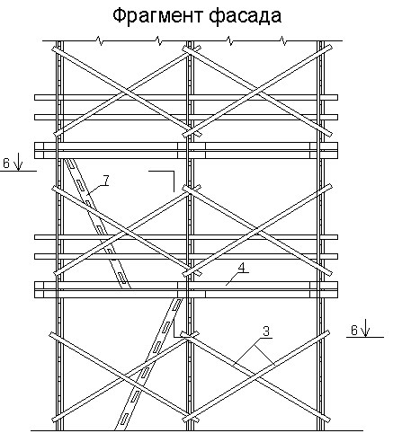 | 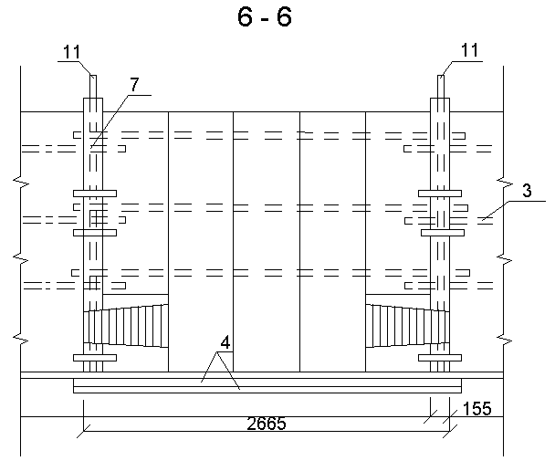  10  10  6.  6.  3
Breakdown of premises
Item No. | name | material
1 | Upright | pine tree
2 | ledger board | ----
3 | Pitch board | -----
4. | Guard board | -----
5. | Landing board | -----
6. | Ribbed-slab filler | ----
7 | Ladder | ----
8 | horizontal middle and top elements | ----
9 | Nails 120-100 mm | ----
10 | Set of fastening of the scaffolds to the wall | ---

Annex C
(finish)

Parameters for the installation of scaffolds

Filled in by the customer:
the object, where the scaffolds are installed
scaffolds place of installation
scaffolds height, m
load on the scaffolds, kg/m²
Filled in by the representative of the contractor organization, who performs the construction and acceptance of the scaffolds:

scaffolds construction
distance between the stands across the front, m
distance between the stands across the width, m
the front length, m
the width of the working deck, m
number of deck floors
the interval between the deck floors, m

Date | position | Signature | Signature clarification | Description of work | page
Date | position | Signature | Signature clarification | Description of work

Annex D
(mandatory)

Log-book form of applications on the assembling and disassembling of scaffolds

LOG-BOOK
of applications on the assembling and disassembling of scaffolds

Started on “____”___________ 20 ___
Ended on “____”___________ 20 ___

First page:

Item No. | Application on scaffolds assembling |  |  |  | Application on scaffolds disassembling |  |  | Disassembling Signature of the Head of the works on assembling and disassembling of the scaffolds (date, full name)
Item No. | Date, time of application | Place of scaffolds installation (workshop, axis, mark, height) | Date of scaffolds installation | Customer’s signature (position, full name) | Date, time of application | Date of scaffolds disassembling | Customer’s signature (position, full name)
1 | 2 | 3 | 4. | 5. | 6. | 7 | 8 | 9

Annex E
(mandatory)

Form of red signal tablet


Full name of the head of works on installation and disassembling of the scaffolds
SCAFFOLDS ARE DANGEROUS FOR EXPLOITATION
THE EXPLOITATION
IS FORBIDDEN!
Company
Phone number:

Annex F
(mandatory)

Form of the Log-book of reception and examination of the scaffolds and scaffolding platforms

Cover sheet:

Log-book of reception and examination of the scaffolds and scaffolding platforms
________________________________________
name of the unit, workshop, site

Started on “____”___________ 20 ___
Ended on “____”___________ 20 ___
First sheet:

Item No. | Place of installation of the scaffolds or the scaffolding platforms,  their height. | Acceptance date.  Act number. | Full names of the persons that performed the delivery and acceptance and inspection of the scaffolds or scaffolding platforms, positions, names of organizations. | Serviceable tag of the scaffolds or scaffolding platforms | Signatures of the persons that performed the delivery and acceptance and inspection of the scaffolds or scaffolding platforms | Special notes
1 | 2 | 3 | 4. | 5. | 6. | 7

Annex G
(mandatory)

Form of the Act of acceptance of scaffolds into exploitation

_____________________________________________________
(name of the organization that accepts the scaffolds)
APPROVED BY:

__________________________
“______” _________ 201___.

ACT No. ____
of delivery and acceptance of the scaffolds into exploitation

from “_____”____________ 201_

The Commission consisting of:

(Position, full name)

Acting on the basis of an order No. _________ from “______”_______ 201__.
on the workshop of the Branch of JSC Ilim Group (contracting organization) having inspected the construction and working state of the scaffolds installed for the performing_
of works have been stated:
the workshop, where the scaffolds are installed
place of scaffolds installation (axis, mark)
the supporting elements are installed
the fencing is installed
the toe-board is installed
the solid deck is installed
the inclined braces are installed
the vertical position of the stands
the number of deck floors
the interval between the deck floors, m
the scaffolds are installed according to MS (for wooden non-standard scaffolds)
Scaffolds inspection result
.
Members of the commission:
____________________________________________________________
(signature, full name, date)
____________________________________________________________
(signature, full name, date)
____________________________________________________________
(signature, full name, date)
____________________________________________________________
(signature, full name, date)

Annex I
(mandatory)

Form of green signal tablet
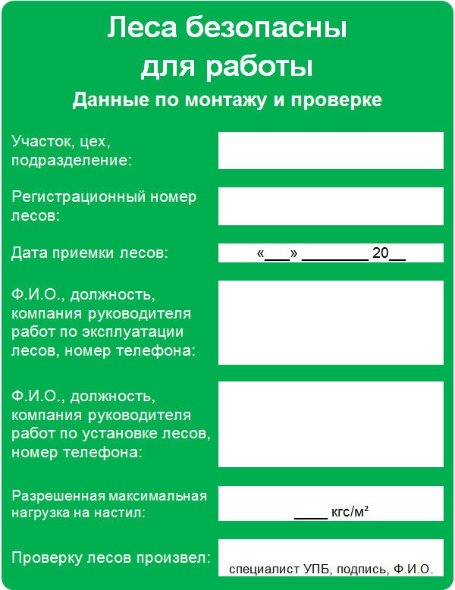
Act No. ____ from ______
of acceptance of the scaffolds into exploitation
The scaffolds are safe
for exploitation
Data on the installing and inspection
Site, workshop,
subdivision:

Registration number of scaffolds:

Scaffolds acceptance date:

Full name, position, company of the head of works on exploitation of scaffolds, telephone number:

Full name, position, company of the head of works on installation of scaffolds, telephone number:

Permitted maximum load for the deck:

The scaffolds inspection was performed by:

kgf/m²:
" "

Annex K
(mandatory)

Form of acts for the configuration and disassembly of scaffolds (scaffolding platforms)

C E R T IF I C A T E
1. On configuration of scaffolds

WORKSHOP of the Branch of JSC Ilim Group in Ust-Ilimsk (contractor organization)

Axis_______________ Row___________________
Mark
Equipment position ______________________Inv. No.
Works description
Approximate scaffolds area: m² of vert. projection _ __H of scaffolds
Deadline:
Urgency
(planned, urgent, emergent)
Agreed by: the Head of structural unit
Working conditions: tight working space, harmfulness
The scaffolds were delivered by: The head of works on installation and disassembling of the scaffolds
(position, full name, signature, date)
The scaffolds were accepted by: The head of works on scaffolds exploitation
(position, full name, signature, date)

C E R T I F I C A T E
2. On scaffolds disassembling

WORKSHOP of the Branch of JSC Ilim Group in Ust-Ilimsk (contractor organization)

Axis___________________Row
Mark
The actual scaffolds area: m² of vert. projection; _______________H of scaffolds__________
The scaffolds were delivered for the disassembly by:
The head of works on scaffolds exploitation
(position, full name, date, signature)
The scaffolds were accepted for the disassembly:
The head of works on installation and disassembling of the scaffolds
(position, full name, date, signature)
The head of subdivision
(Full name, date, signature)

Annex L
(mandatory)

The form of the Act for coordinating the placement of materials and equipment in the workshop area

Act for coordinating the placement
of materials and equipment in the workshop area

Contractor organization:
Full name of responsible person:
Contact telephone number:
Name of the stored materials, equipment:

The volume of the stored materials (m³):
Purpose of placement:
Location of the placement of materials, equipment:
structural unit
surrounding area
mark ________________ axis ___________________row

Temporary placement from “___” ____________ 20__. till “___” ____________ 20__.

Requirements for the placement of materials, equipment:
the storage area scheme is attached;
it is not allowed to block the approaches to fire protection means and evacuation routes;
it is not allowed to clutter the passages through the territory;
at the place of storage there is a tablet with information about the responsible person (position, full name) for storage and contact phone;
the heat sources, electrical panels, electric motors and starting equipment at a distance of not less than 5 meters are absent;
the storage location is enclosed by the warning tape.
does not prevent the maintenance of equipment.

Other requirements necessary to ensure fire safety:
____________________________________________________________________________
____________________________________________________________________________
____________________________________________________________________________
____________________________________________________________________________

(Head of the unit that places materials, equipment; signature, date, full name)

Approved by:

(Head of the subdivision, signature, date, full name)

(representative of the Fire Safety and Emergency Service, signature, date, full name)

(representative of the chief ecologist service, signature, date, full name)

(representative of the Directorate for Labor Protection and Industrial Safety, signature, date, full name)
Annex K
(finish)

Note:
- The approval of the Act is obligatory:
- with the head of the unit, in whose territory the materials, equipment are placed
- with the representative of the fire safety and emergency response service

- Coordination with the representatives of the directorate for labor protection and industrial safety, the service of the chief ecologist is carried out at the request of the head of the subdivision in whose territory materials, equipment are placed

Diagram
installation (storage) places

Developed by:

(Position of the FS responsible person) (Signature) (Full Name)

Approved by:

(Position of Head of Unit) (Signature) (Full Name)

DOCUMENT REVISION SHEET

Number of the amendment | Name, date, number of the administrative document | Pages with the amendments | List  of the amended sections  (sub-sections, paragraphs)

