Branch of JSC ILIM Group in Ust-Ilimsk

APPROVED
Director on Labor Protection and
Industrial Safety
G.Yu. Sirotina

“______”___________________2017.

MANUFACTURING DIRECTIVE

on safe operation
with hoisting machineries
operated from the floor

И ПБ 01-02

To replace

Introduced by:
(name of the document, date, document number)

Introduction date:
(day, month, year)

Ust-Ilimsk
2017

TABLE OF CONTENTS

1 | Purpose | 3
2 | Scope | 3
3 | Terms and Definitions | 3
4 | General Provisions | 4
5 | Duties before the start of work | 5
6 | Duties during the work | 6
7 | Actions in emergency situations | 9
8 | Duties at the end of the work | 10
9 | Responsibility | 10
Addendum 1 Hand signal when moving cargos with the use of the HM (except for lifts (towers)) |  | 11
Addendum 2 Main reasons of HM failures |  | 12
Addendum 3 Violations of industrial safety requirements under which the HM operation should be prohibited |  | 13
Acknowledgement List |  | 21
1. PURPOSE

This Directive is directed to fulfilling the requirements of the control system of Branch of JSC Ilim Group in Ust-Ilimsk (hereinafter referred to as the Branch) on the basis of a labor protection and industrial safety management system and establishes the requirements for the safe exploitation of hoisting machineries controlled from the floor and defining of duties for the workers who use them.

2. SCOPE

This Instruction is obligatory for application by the workers performing works with load-lifting machines controlled from the floor, as well as performing works on strapping, hooking, fastening the load (container) and hanging it on the hook of load-lifting machines controlled from the floor by means of rope slings or special load-handling devices.

3. TERMS AND DEFINITIONS
Accident - destruction of constructions and (or) technical devices used at the hazard production facility, uncontrolled explosion and (or) release of hazardous substances
Incident - the failure or damage of technical devices used at a hazardous production facility, deviation from the technical process mode, violation of provisions of the current legislation and other regulatory legal acts of the Russian Federation, as well as normative technical documents establishing the rules for performing the works at a hazardous production facility
Hoisting machineries (hereinafter referred to as HM) - load lifting cranes of all types, bridge stacker cranes; pipe-layer cranes, loader cranes, construction site hoists, lifts and towers intended for moving people, cargo electric carts moving on the above-ground tracks along with the control cab; electric hoists, excavating cranes, designed to work only with a rope-supported hook, or an electromagnet);
Industrial safety of hazardous production facilities is a state of security of the vital interests of the personality and society from the accidents on hazardous production facilities and the consequences of the specified accidents.
The manufacturing directive is the document establishing obligatory requirements for execution by the staff for the safe performance of works during exploitation and (or) service of hazardous production facilities.
Production control is a part of the industrial safety management system implemented by carrying out a complex of measures aimed at providing the safe operation of hazardous production facilities, as well as at preventing accidents on these facilities and ensuring readiness for localization and elimination of their consequences.
Rostechnadzor is a Federal Service for Environmental, Technological and Nuclear Supervision (The Gosgortechnadzor of Russia was a part of this service).
Branch is a Branch of JSC Ilim Group in Ust-Ilimsk.
Roping is a technological operation performed in the process of lifting and moving cargo in order to connect the latter with a HM. The roping is performed by the strapping, fastening (capture) the load or hanging the cargo on the hook of HM, using, as a rule, hoisting machineries.
Cargo sling (harness) is a removable load gripping device, which basic part is the flexible connecting element made from a piece of rope, chain or a textile tape. The bridle sling, depending on the execution, includes one or several branches equipped with a link for hanging on the HM and captures for the cargo. For the direct strapping of cargo the slings can be round or, in addition, with loops or links on the ends.
Industrial safety requirements – conditions, prohibitions, restrictions and other obligatory requirements which are contained in Federal laws and other regulatory legal acts of the Russian Federation as well as in the regulatory legal acts (state standards, safety rules, instructions) adopted in accordance with the established procedure.
DPC - department of production control.

- GENERAL PROVISIONS

4.1 When developing this manufacturing directive are used the relevant legislative and regulatory documents in the LB field, indicated in the register placed on V:\State Property Fund in Ust-Ilimsk\Labor protection and industrial safety\Industrial safety\Exploitation of HIF.
4.2 This manufacturing directive establishes the requirements for safe operation with HM application, controlled from the floor (HM not subject to registration in the bodies of Rostechnadzor).
4.3 Compliance with the requirements of this directive is a necessary condition for providing the labor safety of workers admitted to work with HM controlled from the floor (hereinafter referred to as the worker).
4.4 The worker authorized to have deal with the HM controlled from the floor and to hook the cargo on such HM, should have a medical report that determines the compliance of his/her physical condition with the performance of such works.
The worker is obliged to notify in due time the direct management about the impossibility for him/her to perform the work in connection with deterioration of his/her health condition.
4.5 To control a HM from the floor and for catching the cargo on the hook of such HM are allowed the workers of the Branch not younger than 18 years old, passed through the special training and probational period on the workplace (not less than 2 shifts).
    - The worker’s training is carried out to the extent of this directive and instructions on labor protection for persons using cranes controlled from the floor (approved in the Branch) in accordance with GOST 12.0.004-90 “OSSS. Occupational safety standards system. General provisions” in the form of briefing in the order established in the Branch.
    - In the course of probational period, the worker is obliged to learn and to pass a knowledge test on the operation manual (directive) on exploitation of the HM, as well as to pass the skill examination on the controlling of HM and on the fastening of cargos on the hook of such HM.
  - If the results of the knowledge test and probational period tests are positive, the employee's admission to work is confirmed by the order for the production unit and a corresponding mark is made in the certificate of knowledge testing on labor protection (if any).
The worker passes at least once in every 3 months a refresher briefing, as well as the briefing:
- in case of the break in work on the specialty for more than 12 months with the obligatory additional probational period (2-3 shifts);
- in case of making a change to this;
- at the request of a specialist responsible for the implementation of production control during the HM exploitation, in cases where insufficient knowledge of this directive is revealed.

  - During the work, the worker is obliged to have a certificate of verification of knowledge on labor protection.
  - Manufacturing Directive is handled to the worker, under the signature.
4.9 The worker obeys:
4.9.1 directly to the specialist responsible for the safe performing of works with HM application;
4.9.2 in the part of the maintenance of the HM in a good working order, to the specialist responsible for maintaining the HM in a good working order.
4.10 The worker is obliged to know and fulfill the requirements: of this directive, of instructions on labor protection in accordance with the work performed, of technological regulations, as well as of the orders and other local regulatory acts of the Branch in terms of maintenance of the HM in a good working order and safe organization of HM exploitation.
  - The worker is obliged to know and to comply with:
- the hand signal (Addendum No. 1);
- the projects of work performing, operation chart flowsheets of cargo storage, technology of handling operations and other safety regulations, sling arrangements available in the workshop (on site);
- the general requirements for safe slinging and hooking of cargos, as well as to the order of movement and placement of cargos;
- the terms and results of the performed technical certifications of the HM;
- the specialists responsible for the maintenance of the HM in a good working order;
- for specialists responsible for the safe working practices using HM, sling operators;
- main reasons of crane failures (Addendum No. 2);
- location and arrangement of fire extinguishment means and the order of their application;
- general arrangement of the HM, rail tracks and its main technical characteristics (lifting capacity, lifting height and load lowering height, permissibility of performing of simultaneous operations, safety devices) and the requirements for safe production of works, represented in the manual (instructions) for operating of HM.
4.12 the worker is obliged to know and be able to identify the HM main faults, as well as cargo ropes, load-handling devices, packings, crane tracks and track equipment (Addendum No. 3);
  - the worker is obliged to know the location of the crane switch, which feeds the crane and be able to disconnect it when necessary, and also to know the location of the medical first-aid kit.
  - Being in a workplace, the worker is obliged to use corresponding personal protective equipment (suit, footwear, helmet, protective glasses, gloves and safety harness if necessary).

5. DUTIES BEFORE THE START OF WORK
  - The worker starts the work after receiving the relevant task from a specialist responsible for the safe work performing using the HM.
  - According to the received task the worker should to be instructed about the order of cargo placement and be informed under the signature of slinging schemes (the correct slinging scheme for standard cargos which don't have special devices (loops, pins, etc.) have to be placed in places of continuous production of handling operations). In case of absence of a slinging scheme the worker is obliged to perform such works at the presence and under the control of the specialist responsible for safe works with HM application.
5.3 When working with the sling operator, the worker is obliged to check at him/her the availability of the sling operator’s certificate and the availability of the mark about the passing the knowledge test in this certificate.
  - Before the putting the HM into the exploitation the worker should:
5.4.1 make sure that the HM passed the technical examination and has no visible defects. The deadline of the next full technical examination is indicated on the tablet with the marking of the serial number and the marked capacity, which has an HM. The full technical examination is performed once in 3 years, partial one yearly;
5.4.2 to perform an external inspection for integrity and serviceability:
- of remote control panel, absence of control button sticking in the jacks and the availability of the steel wire on which the remote control panel is suspended;
- of hook and hook assembly (including fastening in the joint, the availability of the splinting screw and the ease of hook rotation in the hook assembly, the availability and serviceability of the lock - the device that closes the hook throat),
- of cargo ropes (at examination of ropes it is necessary to pay attention to correctness of rope laying in pulley grooves and drum grooves),
- of the current-carrying cable,
- of buffer devices and track buffer stops.
Examination is performed with the turned-off remote control panel;
5.4.3 to test the state of serviceability of all HM mechanisms, by sequential short-term turning on of the operations;
    - to check the state of serviceability of the limit switch hoisting tumbler. After the limit switch operation the gap between the load-handling device (without cargo) and the stop of the electric hoist must be at least 50 mm;
5.5 Prior to starting the operations related to lifting, moving and putting down the cargo (hereinafter referred to as cargo processing), the worker is obliged:
- to choose the serviceable load-handling devices that correspond to the mass and nature of the lifted cargo (in accordance with the slinging scheme) and to check their serviceability and the availability of stamps or labels on them with the serial number and carrying capacity, the date of testing and the manufacturer's mark. The integrity of the load-handling devices is checked before each operation on the cargo hooking;
- to check the integrity of the packaging and the availability of marking about its purpose, number, empty weight and the maximum cargo weight on it;
- to check availability and serviceability of necessary tools and auxiliary inventory devices (slings, timber hitches, hooks, ladders, platforms, supports and gaskets, pans, special stoppers (slippers) and special metal horses necessary during the work with vehicles, etc.);
- to examine the workplace, if necessary, to put it in order, to clear the passages and further not to obstruct them;
- to check the sufficient illumination of a workplace. In case of insufficient illumination it is necessary to inform the specialist responsible for the safe performing of works
5.6 The worker is prohibited from:
- the performing of HM work until the elimination of the revealed faults, damages and defects (Addendum No. 3), as well as if the term of the next regular full technical examination is violated;
- to apply the gaskets which don’t correspond to the character of the placed cargo (for example the gaskets of round cross-section during the warehousing of construction materials in a stack);
- to perform any repairs or maintenance of HM, load-handling devices, to connect the links of the chains with the screws or wirelines, connect the ropes.
5.7 All disadvantages and faults shall be notified to the specialist responsible for the safe production of works using HM.
5.8 The removable load gripping devices and containers recognized as unworkable to use including the lack of necessary marking as well as the load gripping devices with the expired term of safe operation (service) shouldn't be located in the work sites.

6. DUTIES DURING THE WORK
  - During performing the work with an HM, the worker should always be attentive, must comply with the requirements set forth in the instructions (manuals), as well as in operation chart flowsheets, work projects (regulations) and sling arrangements, work together with the sling operator and to remember that his safety and the safety of other workers depends on it.
  - At emergence of need to perform a one-time job with which the worker is not familiar, he/she should stop the work immediately, inform the specialist responsible for the safe conduct of works using HM and only in accordance with his/her instructions and under his/her control the worker can start the work.
6.3. The worker is obliged to perform the works at the presence and under the control of the specialist responsible for safe works with HM application in the cases provided by local normative documents, projects or production schedules.
6.4. The worker before hooking a cargo on the HM hook is obliged:

- previously to examine the place where it is necessary to lower the cargo and to make sure of impossibility of falling, capsizing or slipping of the cargo, if necessary, to lay strong gaskets for convenient removal of the load-handling devices;
- to check the cargo weight according to the list of cargo weights (weight is indicated in regulations, slinging schemes or by marking the cargo (the accompanying document). If it is not possible to determine the cargo weight, it is necessary to inform the specialist responsible for the safe performing of works using HM and to learn the cargo weight from him in writing;
- to make sure that the cargo intended for lifting is not freezed to the ground, it is not fastened, pinched, jammed and there are no foreign objects (other cargoes) on it, as well as before lifting of large diameter pipes it should be additionally checked that there is no soil, ice or objects that could fall out during the lifting process inside and to make sure that the cargo is stable and correctly placed on the pans;
- to make sure that the remote control is not damaged and the length of its supply cable allows the worker to be at a safe distance during the control of the HM;
- during the handling operations from the vehicles, to make sure that their installation allows safe work, the wheels are equipped with stops, the engine of the vehicle is stopped.
6.5. The worker is obliged to make a hooking of cargo in accordance with the schemes of slinging cargo at the same time:
- the hooking of reinforced concrete and concrete products, as well as other cargoes provided with loops, eye screws, trunnions, to make for all the loops, pins, trunnions provided for lifting in the appropriate position, while other loads and foreign objects should not be placed on these cargoes;
- to fasten the not used for hooking ends of the multi-arm straps in such a way, that when the cargo is moved by a crane, it will be not possible to touch them by the objects encountered on the way;
- the hook of the lifting mechanism should be installed above the cargo in such a way that when the cargo is lifted, the oblique position of the cargo rope must be excluded;
- the roping of long cargos, in order to ensure equilibrium, should be made with the help of minimum two straps, and if the cargo surface is smooth (pipes, poles), it is necessary to use wooden gaskets to prevent the cargo from slipping.
6.6. The worker during the cargo handling is obliged:
- before cargo lifting to make sure that the cargo is securely fastened with load-gripping devices and that the condition of the cl. 6.4.3 of this directive is met;
- to lift the cargo to a height of 200-300 mm, to check the correct function of the roping, the uniformity of the tension of the slings, to make sure that the brakes are working (the cargo should not be lowered spontaneously) and only then to continue the further cargo movement, in case of re-roping the cargo should be lowered.
- before lifting or lowering the cargo make sure that people (including the vehicle's driver) have left the hazard area and only then continue the work. Only the worker (or sling operator) himself can be near the cargo during its lifting or lowering, if the cargo is lifted to a height of not more than 1 m. from the level of the ground on which it is located;
- when moving the cargo which is near an obstacle (wall, column, vehicle (their parts), etc.) it is necessary previously to be convinced of absence of people between the moved cargo and an obstacle;
- before the horizontal movement of cargo, the empty load-gripping machine or load-gripping devices first to raise them on a height not less than 500 mm higher than the objects which are found on the way;
- to watch, by continuous maintenance that the cargo didn't move over people, and couldn't be hitched for something that there was no crossing or an oblique tension of cargo ropes of HM, for the correct winding of the hoist cable on a cargo drum and not to allow the complete stringing the hoist cable from the drum (on the drum should remain not less than one and a half cable rounds, rounds of fastening the cable with the clamping rails shouldn’t be considered). The worker must be on the side of the open part of the drum;
- works related to installation/disassembling should be carried out with the minimal speed and with the special care and at the same time it is necessary to ensure that there are no distortions, jams and vertical movement of the cargo until it is completely removed from the bolts;
- during the jacking of the vehicle part (hereafter referred to as HM), the special supporting stops (shoes) must be placed at first under the unlifted wheels on both sides, then the HM is jacking and is placed under the jacked part of the horse, then the HM is lowered on them;
- when removing and installing the devices (units) of HM, if necessary, to use special supports (jack horse, trolley, etc.);

- cargo handling of loose and small-sized cargoes to perform in a specially designed container, which excludes the possibility of falling of individual cargoes;
- to perform the cargo stacking evenly, without violation of the established dimensions for warehousing or locations of cargos and without blocking up the passes and escape routes that there was always a free access to the crane switch;
- the cargo stacking and removal of cargos from the vehicle should perform without disrupting its balance while the HM engine must be stopped;
- the loading of the sent cargoes in motor vehicles and other self-propelled vehicles to perform in such a way that the convenient and safe roping of cargoes is ensured during their subsequent unloading;
- to remove slings from the cargo or a hook only after the cargo is reliably fastened, and is fixed if necessary;
- to make combination of movements (crane operations) only according to the instructions which are contained in the operation manual of HM, at the same time the simultaneous turning on of the mechanisms shouldn't be allowed;
- to bring the crane or electric hoist to the deadlock stops without accelerating the movement;
- to lower the load, to stop the work of the crane in case of cracks, beatings, knocking, rumbling in the HM mechanisms or in case of detection of any malfunctions, damages or defects of the HM, as well as in case of falling ropes from drums or blocks, loops or detection of damages, and to report the specialist responsible for the safe performing of works with the use of HM.
6.7. The worker during the work is forbidden:
- to move the cargo in case of finding the people who aren't related to work in a dangerous zone of cargo movement, including the loaders and drivers at loading-unloading of the HM who are in the body or a cabin of the HM;
- to use defective load-handling devices, as well as those that do not have tags or stamps;
- to switch on the HM mechanisms when people are near them (except for the cases of examination of HM by the specialist who regularly monitors the device, during such examination the worker can switch on the mechanisms only by the signal of the examining specialist);
- to lift people or cargo with people on it, as well as cargo, leveled by the weight of people or supported by their hands;
- to lift and to move the unstable cargo, as well as cargo, slinged or hooked not in accordance with the slinging schemes or hooked for faulty loops, eyebolts, as well as jammed (other cargo is on the cargo), frozen cargo, bolted cargo;
- to swing the cargo in order to detach it;
- to free by the means of HM the clamped load-gripping devices (slings);
- to move the cargo whose weight is unknown;
- to pull the cargo on the ground, rails and lags when the ropes are in the oblique position;
- to move the packaging filled to the brim or the filling line, or the cargo laid on pans without fencing. As an exception, it is allowed to lift only a brick in pans without fencing when loading it (and unloading it to the ground) on the motor vehicles and trailers;
- to move the trolleys and vehicles using the HM;
- to lift cylinders with compressed and liquefied gases, not packed in the special containers;
- to move cargo over production or service premises where people can be, without previously convinced of their absence in the zone of cargo movement;
- to use a crane for cargo moving when performing construction, painting and other works from the crane bridge. These works have to be performed according to the safe work permit determining security measures, in particular measures for prevention of falling of people from the crane, electroconvulsive shocks, an exit to crane ways, collisions of cranes;
- to perform work in case of insufficient illumination of the HM work place, with poor visibility of signals of the sling operator or the moved cargo; when the air temperature is lower than the indicated in the HM passport;
- to twist cargo in the absence of the developed technology, which should reflect the sequence of operations, the method of slinging cargo and instructions for the safe performance of work;
- to perform the further work at emergence or detection of malfunctions of HM till their elimination;
- to deactivate safety devices (to wedge contactors, to disable lifting height limiters, electrical protection, etc.), and also to perform the work of the HM in case of their malfunction;
- to give up the control of HM before completion of works;
- to make a transfer from the forward stroke to the reverse until the mechanisms stop completely, except the cases when it is necessary to prevent a failure or an accident;
- to transfer the control of the HM to persons who do not have the right to do so, and also to allow students and trainees to the solo operation of the HM without monitoring their actions.

7. ACTIONS IN EMERGENCY SITUATIONS
7.1. In case of an accident the worker is obliged:
    - to stop the work;
7.1.2. If possible, to lower the cargo and to take measures to prevent unauthorized persons from
the entering the accident site;
7.1.3 to notify the direct manager and the specialist responsible for the safe performing of works with the use of the HM;
7.1.4. To preserve the scene of the accident, if this does not pose a danger for the life and health of people and the environment.
7.2. In the event of an accident, as well as the occurrence of cracking, beating, knocking, rattling in the mechanisms or other hazards that may cause an accident, the worker should immediately stop the movement of the cargos, give a warning sound signal, to lower the load to the ground (floor, site) and find out the cause of the incident (the appearance of unwanted sounds).
  - If an accident occurs during the work, the worker should immediately stop the work, provide first aid in accordance with the inter-sectoral instruction on first aid in case of accidents at work, to inform the specialist responsible for the safe performing of works using the PS and to ensure the preservation of the accident scene, if this does not represent a danger to life and health of people.
- In the event of a threat of destruction of inter-floor coverings or walls of a building, crane tracks or crane rails or in the event of natural disasters, the worker should stop the work (to lower the load) to de-energize the HM and to leave the hazard area.
- In the event of a fire on the HM, the worker should immediately stop the work, switch off the main power switch, call the fire department and start extinguishing the fire with the available fire extinguishment means.
- If the power supply is suddenly disconnected or the HM is stopped for other reasons, and if the cargo is left in the raised position, the worker is obliged to call a specialist responsible for the safe work with the HM with the help of slinger or other workers and follow his/her instructions. Before arrival of the responsible specialist the worker shouldn't allow stay or pass of people under the lifted cargo.
- If the HM elements have appeared energized, the worker is obliged to follow the measures of personal security and to switch-off the supplying switch.
- In the event of other emergencies, the worker must comply with the safety requirements set out in the operating manual of the HM.
- The worker is obliged to inform the direct management of all emergency situations.

8. DUTIES AT THE END OF THE WORK
8.1 After the termination of work the worker is obliged:
- to free the hook from the cargo or the load-handling device;
- to raise the hook to the upper position;
- to park the HM on the parking place established in the unit;
- to switch off the power switch and to lock it;
- to place the remote control at a height of not less than 1-1.5 m from the floor.
8.2. On all available remarks revealed during the work the employee is obliged to in form the specialist responsible for the maintenance of the HM in good working order.

9. RESPONSIBILITY

9.1 The worker guilty of violating this production directive shall be liable in accordance with applicable law.

The main specialist on the Production Control I.T. Shefibeyli

Head of the Production Control Department M.A. Soloviev

Approved:

Maintenance Manager S.V. Goncharenko

Addendum No. 1

Hand signal
when moving cargos with the use of HM (except for lifts (towers)

Action | Figure | Signal
To lift cargo or hook | 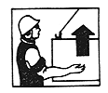 | The intermittent hand movement up at the level of the waist, the palm is turned up, the arm is bent in an elbow
To lower cargo or hook | 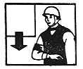 | The intermittent hand movement down before the breast, the palm is turned down, the arm is bent in an elbow
To move the crane (bridge) | 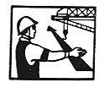 | The movement with an outstretched hand, the palm facing the direction of the desired movement
To move the cart | 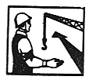 | The hand movement with the hand bent at the elbow, the palm facing the desired movement of the cart
To turn the gib arm | 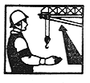 | The hand movement with the hand bent at the elbow, the palm facing the desired movement of the gib arm
To lift the gib arm | 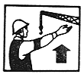 | Moving upward with an outstretched hand, previously lowered to a vertical position, the palm is opened
To lower the gib arm | 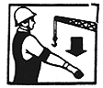 | Moving downward with an outstretched hand, previously raised to a vertical position, the palm is opened
Stop (stop the lifting  or moving) |  | The quick hand movement to the right and left at waist height, the palm is turned down
Attention (applies before the above mentioned signals if minor movement is necessary) |  | The hands are with palms facing one another at a short distance, hands are raised upwards

Addendum No. 2

MAIN REASONS OF HM FAILURES
In the production of works with HM periodically occur the failures and accidents, the main causes of which are:
- incorrect (unreliable) slinging of cargo;

- the use of non-serviceable removable load-handling devices or containers for lifting cargo;

- the presence of people in the hazard area or under the HM gib arm;

- the violation of schemes of cargo slinging;

- the violation of technological maps of handling operations;

- the presence of people in a gondola wagon, on a platform, in a car body, ship's hold, trench, excavation, well during the lifting or lowering cargo;

- the non-observance of schemes and dimensions of cargo storage;

- the presence of people between the revolving and non-revolving parts of the HM;

- the admission of untrained workers to work with the HM as slingers;

- the yarding of cargo with the use of HM at an oblique position of cargo ropes;

- the presence of people in the cab of the car during the unloading or loading process;

- the overload of the HM during the lifting of the frozen, covered with soil, bolted, cramped or covered with concrete cargo;

- the presence of people near a wall, column, stack or equipment during the lifting or lowering the cargo;

- the malfunction of the crane track and dead-end stops;

- the breakage of cargo or gib arm ropes.

Addendum No. 3

VIOLATIONS OF INDUSTRIAL SAFETY REQUIREMENTS DURING WHICH THE OPERATION OF HM SHOULD BE PROHIBITED

- The maintenance of the HM is performed by unauthenticated personnel, the instructions for ensuring safe operation of the HM have not been issued by the responsible specialists of the Branch or by the Rostekhnadzor inspector of the instruction on ensuring the safe operation of HM.
- No specialist responsible for the implementation of production control in the exploitation of HM, no specialist responsible for maintaining the HM in a good order; no specialist, responsible for the safe production of works using the HM has not been appointed.
- The terms of technical examination, repair, maintenance or expert examination have expired.
- There are no removable load-handling devices and containers that are suitable for weight and type of transported cargos, or they are non-serviceable, the passport of the HM or information on its registration with Rostekhnadzor (for the nonregistered accountable HM) is missing or lost.
- The work is carried out without fire prevention rules, in-process monitoring, safe work permits, no measures for safe operation and the requirements set out in the fire prevention rules, in-process monitoring, safe work permits are performed, the work is carried out with violations of federal rules and regulations, fire prevention rules, in-process monitoring and instructions, which can lead to an accident or threat to human lives.
- Technical faults were detected at the HM:
- cracks or residual deformations of metal structures (the latter higher than the permissible limits);
- weakening of fastenings in joints of metal structures;
- inefficiency of grounding of hydro- or electrical equipment;
- the non-serviceability of pointers, limiters and recorders, control system; - inadmissible wear of hooks, ropes, chains, elements of mechanisms and brakes, of the rail track.
REJECTION LIMITS OF ELEMENTS OF CARGO CARRIAGE MACHINES

Crane elements | Defects in which presence the element is rejected

Running wheels of cranes and carts | 1. Cracks of any size  2. The galling of the flange surface up to 50% of the original thickness  3. The galling of the rolling surface, which reduces the original diameter of the wheel by 2%  4. The difference in the diameters of the wheels with interlocked motion more than 0.5% *
Blocks | 1. The wear of the block's groove more than on 40% from the original radius of the groove
Drums | 1. Cracks of any size  2. The wear of the drum groove along the profile more than 2 mm
Hooks | 1. Cracks and tears on the surface  2. The wear of throat more than 10% of the original height of the vertical section of the hook
Brake  drums | 1. Cracks and breaks on the working and landing surfaces  2. The wear of the working surface of the rim more than 25% of the original thickness
Brake  linings | 1. Cracks and breaks, suitable for rivet holes  2. The wear of the brake lining in thickness before the appearance of rivet heads or more than 50% of the original thickness

- Defective or missing interlocks, sound warning device, limit switches of lifting mechanisms, movement of the crane or cart.
- There are no fences for mechanisms or uninsulated current-carrying parts of electrical equipment, as well as the grounding is absent or damaged.
- In case of false alarm of the electrical, thermal or other protection of the crane, as well as safety devices.
- In case there is a voltage on the motor body, the controller, the apparatus casing, the hook or the metal structures of the crane.

REJECTION NORMS OF STEEL ROPES OF LIFTING CONSTRUCTIONS
(including steel ropes of slings)

11. The cargo rope has a number of wire breaks or wear that exceeds the norm established by the operating manual of the crane, as well as teared strand or local damage, namely the following criteria:
а) the nature and number of wire breaks (figures 1 - 3), including the presence of wire breaks at the endings, the presence of places where the wire breaks are concentrated, the intensity of the increase in the number of wire breaks;
b) the strand break;
c) surface and internal wear, as well as surface and internal corrosion in which the rope diameter has decreased by 7%;
d) local reduction in rope diameter, including core breakage by 3% for non-twisting ropes and by 10% for the rest ropes;
e) reduction of the cross-sectional area of the rope wires (inside dimension
losses);
f) deformation in the form of rippling, birdcaging, extrusion of wires and strands, crushing of strands, bends, kinks;
g) damages due to temperature influence or electric arc discharge;
h) reduction of the initial diameter of the outer wires due to wear or corrosion by 40 percent.



Figure 1. Breaks and displacements of wires of the reverse-laid rope

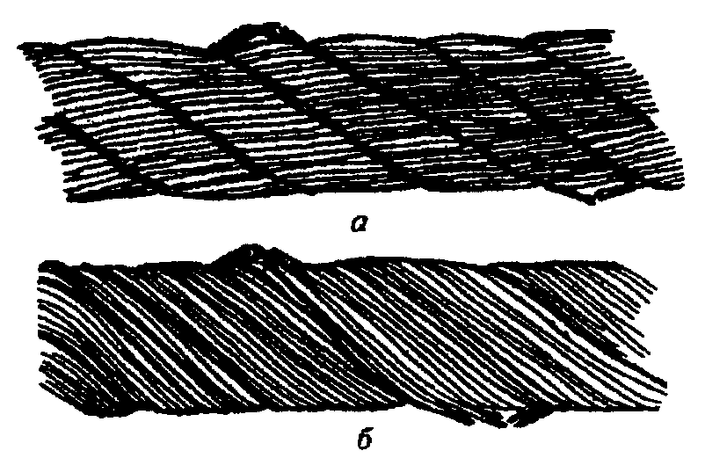
b

Figure 2. Combination of wire breaks with their wear:
a - in the reverse-laid rope; b - in the plain-laid lay rope

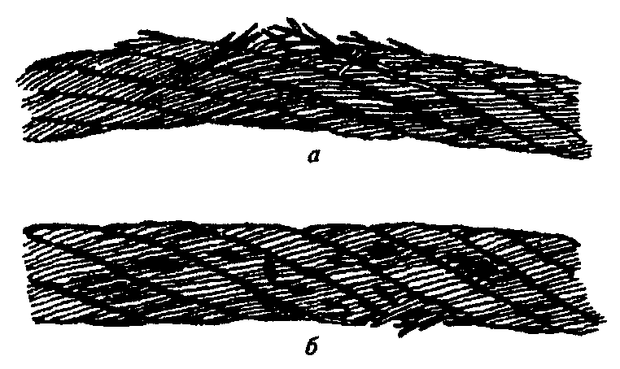
b

Figure 3. Wire breaks in the rope balancer area:
a - in the several rope strands; b - in two strands combined with the local wear



Figure 4. Local reduction in rope diameter at the site
of destruction of the organic fiber core


Figure 5. Reduction of the cross-sectional area of the wires (intensive internal corrosion)

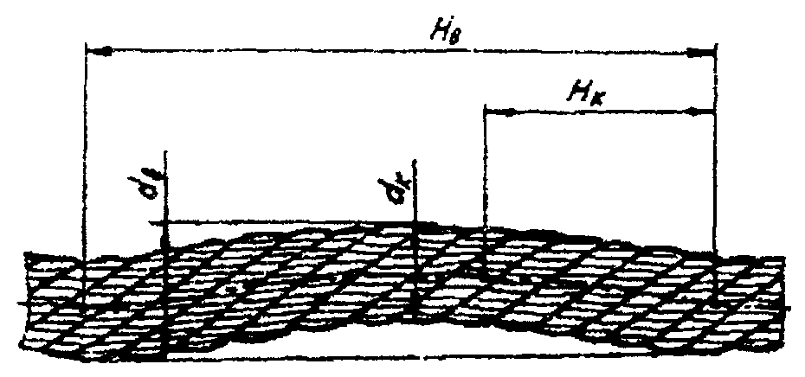

Figure 6. The rippling of the rope (explanation in the text)

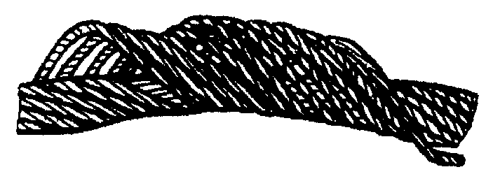

Figure 7. Deformation in the form of birdcaging

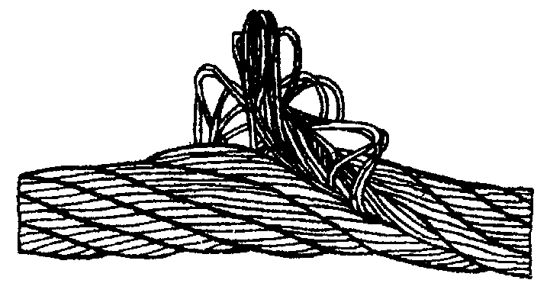

Figure 8. Сore protrusion

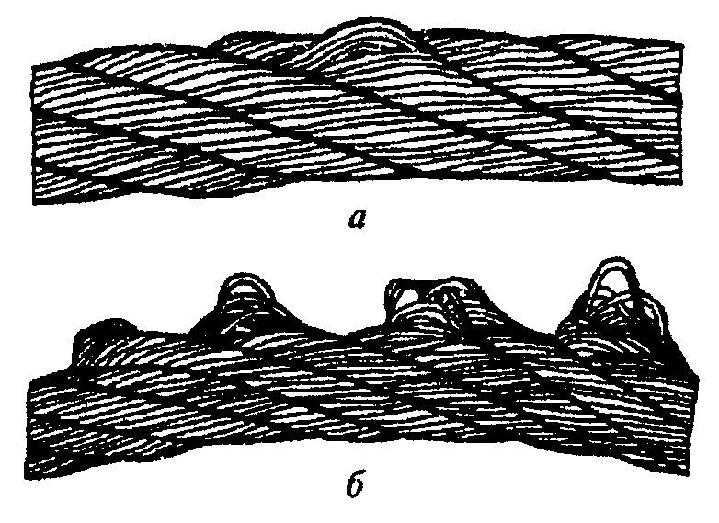
b

Figure 9. Wire strand protrusion: a - in one strand; b - in several strands



Figure 10. Local increase of cable diameter



Figure 11. Crushing of the cable
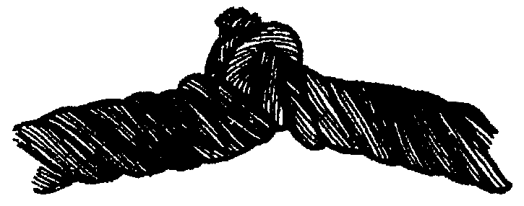

Figure 12. Twisting of the rope

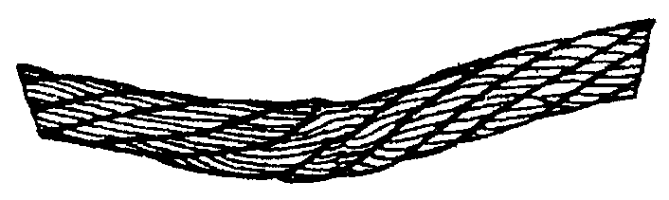

Figure 13. Jamming of the rope

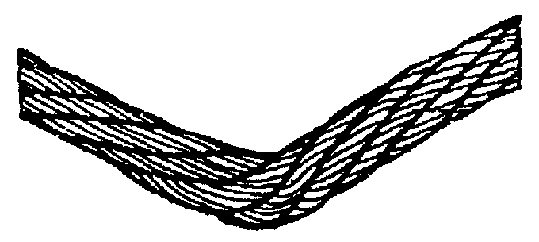

Figure 14. Kinking of the rope

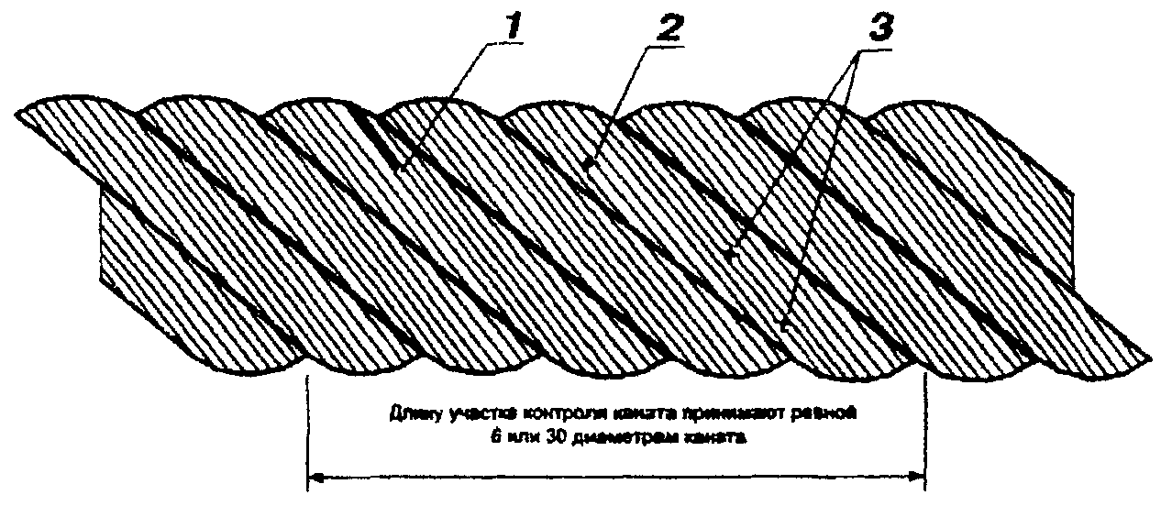
The length of the rope control segment is taken to be 6 or 30 of the rope diameter

Figure 15. The example of determining the number of breaks of the outer
wires of the steel rope:
1 - only one end is found at the control site at the broken wire, the counter end of the broken wire is absent. This defect corresponds to one break;
2 - there are two ends at the broken wire on the control site. This defect corresponds to one break;
3 - on the control site one of the wires has a double integrity violation. Since the integrity violations belong only to one wire, this defect corresponds in total to one break

- The rope attachment clamps are damaged or missing or their bolts are loosened.
- If the rope is incorrectly laid or dropped from the drum or blocks and in case of revealing the rope damage.
- When twisting the ropes of the hoisting tackle.
- Rope blocks or hoisting tackles are damaged.
- Crane rails are non-serviceable:

REJECTION CRITERIA OF THE CRANE RAILS

16.1 The crane rail of the support HM is subject to rejection in the presence of the following defects and damages:
- cracks and spalls of any size, the fastening of the rail is weakened, there is no (disconnected) breaking straightedge or track buffer stop;
- vertical, horizontal or wear resistance (vertical plus half of horizontal) of the rail head more than 15% of the corresponding size of the unworn profile;
- the spalls of concrete before the laying bare of reinforcement in concrete sleepers, as well as other spalls of concrete in a section of more than 250 mm in length;
- the solid surrounding or longitudinal cracks longer than 100 mm with an opening of more than 0.3 mm in reinforced concrete sleepers;
- the fracture, transverse cracks with a depth of more than 50 mm and a length of more than 200 mm, superficial sap rot of more than 20 mm under the battening plates and more than 60 mm on the remaining surfaces in wooden half-sleepers.

LIMIT VALUES OF CRANE RAILS DEVIATIONS FROM THE PROJECT POSITION IN THE PLAN AND PROFILE

Deviation, mm | Graphical representation of the deviation |  | Cranes
Deviation, mm | Graphical representation of the deviation | bridge | full gantry, portal slewing | loading cranes
The difference in the marks of the rail heads in one cross-section Р₁,  S-dimension of the track (bay) | 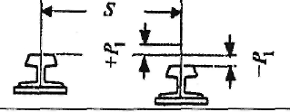 | 40 | 40 | 50
The difference in the marks of the rails on the neighboring columns Р₂, | 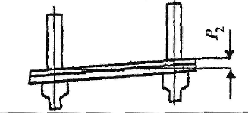 | 10 | - | -
Narrowing or widening of rail track  (deviation of dimension bay — S in the plan) Р₂ | 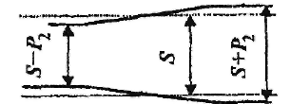 | 15 | 15 | 20
■  Mutual displacement of the ends of the joined rails in plan and in height Р₄ | 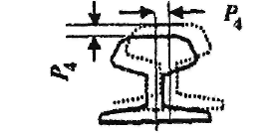 | 2 | 2 | 2
Gaps in the rail joints at 0 °C and rail length 12.5 m, Р₅ | 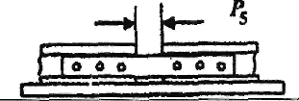 | 6 | 6 | 6
The difference in elevation marks of railheads at a length of 10 m of the crane track  (total) Р₆ | 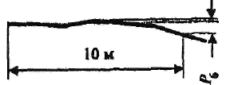 | ** | 30* | 30

Notes. 1. Measurements of deviations Р₁ and Р₂ are performed on the whole section of the possible crane movement in the intervals not more than 5 m.
2. In case of temperature change for every 10 °С the gap set at the device Р₅ is changed by 1.5 mm, for example, at a temperature of plus 20°С the established gap between the rails should be 3 mm, and at a temperature of minus 10 °С - 7.5 mm.
3. * - for portal slewing gantry cranes 20 mm.
4. ** - 10 mm for BC-20/5; 15 mm for FGC-20+20.

16.2 The monorail way of suspended electric hoists and trolleys is subject to rejection if there are:
- cracks and indents of any size;
- reduction of the total width of the rail belt (flange) due to wear ΔB ≥ 0.05 from the original width of the flange B;
- decreasing the thickness of the rail flange due to wear Δδ ≥ 0.2 from the initial thickness of the flange δ at a distance from the edge of the flange (B - t) / 4, where t is the thickness of the vertical wall of the monorail, by the simultaneous bending of the flange f ≤ 0.15 delta.
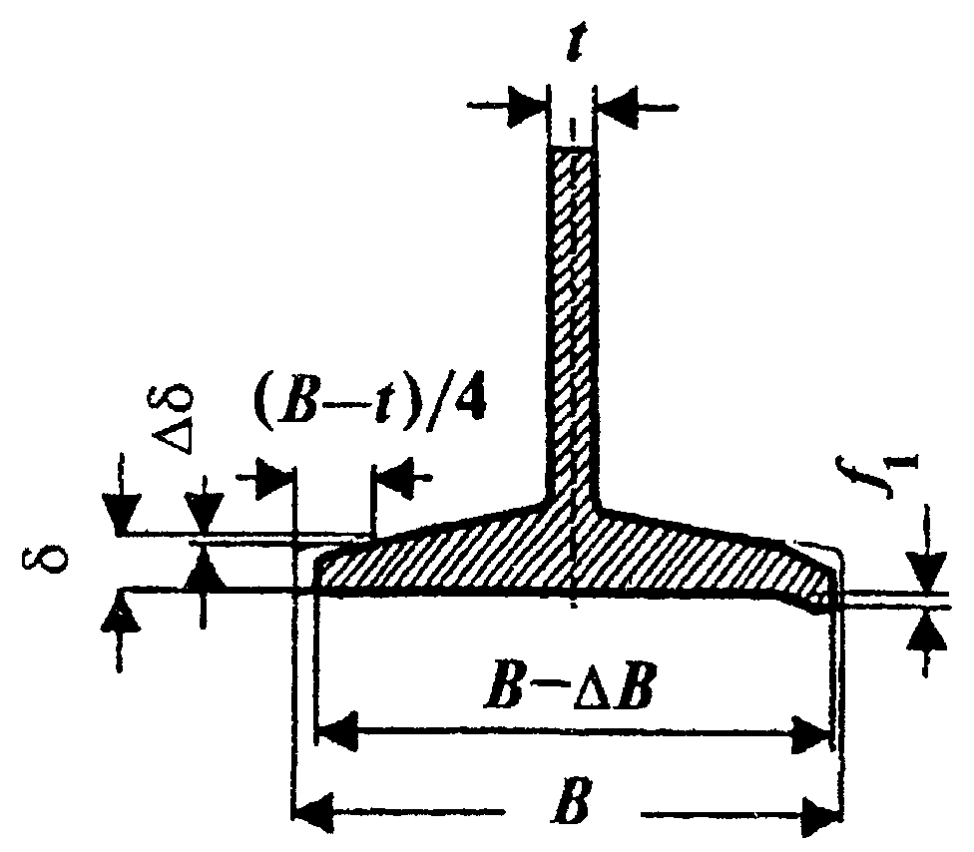

Scheme for measuring the wear and bending of the monorail flange when carrying out its
defect:
B - initial width of the flange; - flange wear; t - wall thickness;
- flange bend; - initial width of the flange at the distance (B-t)/4 from the edge;
- reducing of the flange thickness due to wear.

STANDARDS OF REJECTION OF THE HOISTING MACHINERY

The rejection of the elements of rope, tape, synthetic and chain slings is made in accordance with the following recommendations:

- The identification tag is missing or is damaged
- The cable rope is to be rejected if the number of visible breaks in the outer wires of the rope exceeds the indicated in the table.

Slings from the double-lay ropes | Number of visible wire breaks on the site of the cable strap with the length
Slings from the double-lay ropes | 3d | 6d | 30d
Slings from the double-lay ropes | 4 | 6 | 16
Note, d – rope diameter, mm.

3. Signs of sling rejections

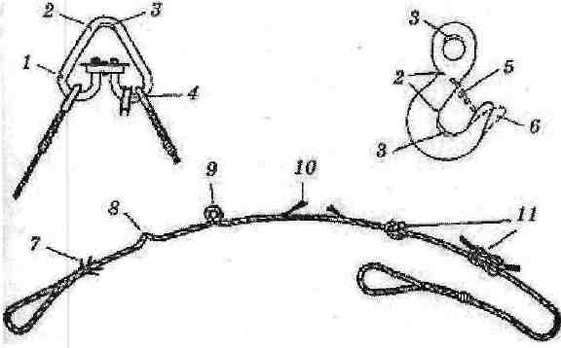

- — tear;
3. Signs of sling rejections
- — crack;
1 – tear;
2 – crack;
3 – wear;
4 – rope eye deformation;
5 – absence of lock;
6 – hook deformation;
7 – the wire ends protrude;
8 – kink;
9 – twisting;
10 – the strand breakage;
11 – knot.
- — wear;
- — rope eye deformation;
- - absence of lock;
- - hook deformation;
- - the wire ends protrude;
- — kink;
- — twisting;

- — the strand breakage;
- — knot.
Fig. Signs of sling rejections:

To assess the safety of using slings, should also be applied the following criteria:
- surface and internal wear, as well as surface and internal corrosion in which the rope diameter has decreased by 7%;
- local reduction in rope diameter, including core breakage by 10%;
- deformation in the form of rippling, birdcaging, extrusion of wires and strands, crushing of strands, bends, kinks etc.;
- damages due to temperature influence or electric arc
discharge;
- there are signs of a rope shift in the splicing or in the clip.

4. The chain strap is to be rejected when the chain link is extended more than 3% from the original size and when the diameter of the chain link is reduced due to wear of more than 10%.

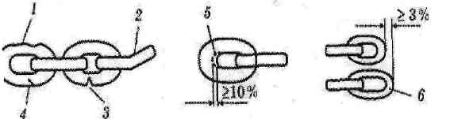

1 — damages; 2 — bent; 3 — tear; 4 — crack; 5 - wear; 6 - elongation.

The chain slings of strength class less than 3 are allowed to use only at positive temperatures: from plus 1 °C to plus 100 °C

5. Textile straps on a polymeric basis and synthetic round, as well as fibrous ropes are subject to rejection if:
- there is no stamp (tag) or information about the sling that contains information about the manufacturer, load capacity;
- there are knots on the carrying strap, ropes;
- there are transverse cuts or ruptures of the strap, rope, regardless of their size;
- there are longitudinal cuts or ruptures of strap, rope, the total length of which exceeds 10 percent of the length of the sling arm, as well as single cuts or breaks longer than 50 millimeters;
- there are local fiberings of sling straps, rope (except for places of edge bonding) on the total length of more than 0.5 meters on one edge seam or on two or more internal seams, followed by a break of three or more stitches;
- there are local bundles of sling straps at the edge bonding point at a length of more than 0.2 meters on one of the outer seams or on two or more internal seams, accompanied by the rupture of three or more stitches of the seam, as well as fibering of the edge of the strap or belt jointing near the loop at the length more than 10 percent of the length of bonding (stitching) the strap ends;
- there are superficial tearing of the strap fibers with a total length of more than 10 percent of the width of the strap, caused by the mechanical action (friction) of the sharp edges of the cargo;
- there are damages of the straps from the influence of chemicals (acid, alkali, solvent, petroleum products) with a total length of more than 10 percent of the width of the strap or length of the sling, as well as single lesions of more than 10 percent of the width of the strap and a length of more than 50 millimeters;
- there is a buckling of fibers from the sling strap to a distance of more than 10 percent of the width of the strap;
- there are through holes with a diameter of more than 10 percent of the width of the strap from the influence of sharp objects;
- there is a local section loss of 10% or more of the rope;
- the breakage of 6 or more selvages or wires of fibrous rope;
- there are burnt through holes with a diameter of more than 10 percent of the width of the strap caused of splashes of molten metal or the presence of three or more holes with a distance between them less than 10 percent of the width of the strap, regardless of the diameter of the holes;
- there is a contamination of straps, rope (petroleum products, resins, paints, cement, soil) more than 50 percent of the length of the sling;
- there is a totality of all the above mentioned defects on an area of more than 10 percent of the width and length of the sling;
- there is an erosion or wear of more than 10 percent of the width of the sling loops.
It is forbidden to use slings with the following defects and damages of metal elements (rings, loops, staples, pendants, clips, carbines, links):
- with the cracks of any size and location;
- with the wear of the elements’ surface or the presence of local dents leading to a reduction in the cross-sectional area by 10 percent or more;
- with the presence of residual deformations, leading to a change in the initial size of the element by more than 3 percent;
- with the damage to the threaded connections and other fasteners.

6. The allowances for the use of slings in the temperature regime:
- it is not allowed to subject the web straps, synthetic round and from fibrous ropes to thermal heating due to friction.

7. Web strap and synthetic round, fibrous ropes

Terms of use | Types of slings and features of their construction
Terms of use | All kinds and types of slings | The method of sealing the ends of loops of wire rope slings
Terms of use | All kinds and types of slings | Crimping by steel rope guards | Crimping by aluminum rope guards
Applicable when ambient temperature is reached | up to + 100 °С | up to - 30 °С | up to - 40 °С

ACKNOWLEDGEMENT LIST
with the Manufacturing Directive for the Safe Manufacturing of Works
with the use of hoisting machineries, controlled from the floor

И ПБ 01-02
_____________________________________________________________________________
(name of the unit)
Item No.  No. | Position  (profession) | Initials, surname | Date | Signature
 | I have read and understood the instruction, received one copy

Head of the unit _______________________________________________________
(workshop, site, department etc.) (signature) (initials, surname)
DOCUMENT REVISION SHEET
to the Manufacturing Directive on the Safe Performing of Works with the use
of hoisting machineries, controlled from the floor

И ПБ 01-02

Number of the  amendment | Name, date, number  of the administrative document | Pages with  the amendments | List  of the amended  paragraphs

